**DE-37 (DME)**



**NUST COLLEGE OF**

**ELECTRICAL AND MECHANICAL ENGINEERING**



**Design and Fabrication of Intake and Exhaust Valve using Electronic Actuation**

A PROJECT REPORT

DE-37 (DME)

***Submitted by***

Aqdas Tariq

Usman Shoukat

Muhammad Ehsan

**BACHELORS**

**IN**

**MECHANICAL ENGINEERING**

**YEAR**

**2019**

**PROJECT SUPERVISOR**

Dr. Raja Amir Azim

**YEAR 2019**

**NUST COLLEGE OF**

**ELECTRICAL AND MECHANICAL ENGINEERING**

**DECLARATION**

We hereby declare that no portion of the work referred to in this Project Thesis has been submitted in support of an application for another degree or qualification of this of any other university or other institute of learning. If any act of plagiarism found, we are fully responsible for every disciplinary action taken against us depending upon the seriousness of the proven offence, even the cancellation of our degree.

**ACKNOWLEDGEMENTS**

For the completion our project, within our defined limits and budget, without letting any obstacle, stymie our progress towards successful fulfilment of all our milestones, we would like to thank the following people.

* Dr Raja Amir Azim
* Jawad Haider Syed

We would also like extend our sincerest gratitude to our family members and friends for their constant support, prayers and at times constructive criticism throughout the duration of this project.

**ABSTRACT**

The main purpose of this project is to control the opening and closing of intake valve of the engine using electronic control system rather than the mechanical linkages (camshaft, rocker arm, and timing belt). By controlling the valve through control system we can improve the overall fuel efficiency of the engine, reduce the emissions of hydrocarbons, reduce the weight of the engine and have better control of the operation of valve i.e., we can have the variable lift and variable valve timing at different Rpm.

**TABLE OF CONTENTS**

**CHAPTER 1 INTRODUCTION 12**

**1.1 Motivation 12**

**1.2 Introduction: 12**

**1.3 Operation 13**

**1.4 Prior Work: 14**

**1.5 Scope: 14**

**CHAPTER 2 LITERATURE REVIEW 15**

**2.1 Engines 16**

**2.2 IC (internal combustion) engines 17**

**2.3 Engines Classification on Basis of Ignition 17**

**2.3.1 Spark Ignition (SI) 17**

**2.3.2 Compression Ignition (CI) 17**

**2.4 Engines Classification on Basis of Engine Cycle 17**

**2.4.1 Four-Stroke Cycle 17**

**2.4.2 Two- Stroke Cycle: 18**

**2.5 Engines Classification on Basis of Basic Design 18**

**2.5.1 Reciprocating 18**

**2.5.2 Rotary 18**

**2.6 Engines Classification on Basis of Position and Number of Cylinders 18**

**2.6.1 Single Cylinder 18**

**2.6.2 In-Line 18**

**2.6.3 V Engine 18**

**2.7 Engines Classification on Basis of Air Intake Process 18**

**2.7.1 Naturally Aspirated 18**

**2.7.2 Supercharged 19**

**2.7.3 Turbocharged 19**

**2.7.4 Crankcase Compressed 19**

**2.8 Engines Classification on Basis of Fuel Input methods: 19**

**2.9 Different Fuels 19**

**2.10 Air and Fuel Induction: 20**

**2.10.1 Intake System 20**

**2.10.2 Carburetors 20**

**2.10.3 Working Principle of carburetor 21**

**2.10.4 Intake valves 22**

**2.11 Valve Timing 26**

**2.12 Variable Valve Timings 28**

**2.12.1 VVT-I 28**

**2.12.2 VTEC 29**

**2.13 Actuation of valves affecting volumetric efficiency 30**

**2.13.1 Fuel Injection: 30**

**2.13.2 Valve Overlap 31**

**2.13.3 Closing Intake Valve After BDC 31**

**CHAPTER 3 ENGINE SELECTION 32**

**3.1 V-4 Engine 32**

**3.2 Glow Engines 32**

**3.3 20-30 CC Engine 33**

**3.4 50 CC Engine 34**

**3.5 70 CC Engine 34**

**3.5.1 Reasons for selecting 70 CC 35**

**CHAPTER 4 ACTUATION METHODS 36**

**4.1 Actuation Methods 36**

**1.1.1 Hydraulic 36**

**1.1.2 Pneumatic 37**

**1.1.3 Electronic 37**

**1.1.4 Hybrid 39**

**4.2 Brief Analysis 40**

**4.3 Power Method Selection 40**

**4.3.1 Pneumatic 40**

**4.3.2 Hybrid 40**

**4.3.3 Electronic Actuators 40**

**4.4 Mechanisms 40**

**4.4.1 Crank Slider Mechanism 40**

**4.4.2 Rack and Cam 41**

**4.4.3 Independent Cams for each valve 41**

**4.4.4 Rack & Pinion 43**

**4.5 Mechanism Selection 43**

**4.5.1 Crank Slider Mechanism 43**

**4.5.2 Rack and Cam 43**

**4.5.3 Independent Cams for each valve 44**

**4.5.4 Rack & Pinion 44**

**4.6 Final Selected Mechanism and Actuation Method 44**

**CHAPTER 5 MECHANICAL DESIGN AND ANALYSIS 45**

**5.1 Concept Block Diagram 45**

**5.1.1 Crank Position & Crank Position Sensor (CPS) 45**

**5.2 Acquired Data 45**

**5.3 Manual Calculations for Mechanism 47**

**5.4 Simulated Excel Model 48**

**5.4.1 Engine Design Parameters Based Simulation 48**

**5.4.2 Empirical Engine Parameters Based Simulation 51**

**5.5 Spring Design 52**

**5.5.1 Requirement 52**

**5.5.2 Prior Assumptions 52**

**5.5.3 Calculations 53**

**5.5.4 Results 54**

**5.6 PTC Creo 3D Concept Model 55**

**5.7 Motion Analysis 58**

**5.8 Simulated Results 60**

**5.9 Final Parameters of Mechanical Design 60**

**5.9.1 Springs Parameters: 60**

**5.9.2 Motor parameters 60**

**5.9.3 Gear Parameters 61**

**CHAPTER 6 ELECTRONIC DESIGN & PARAMETERS 62**

**6.1 Electronic Components 62**

**6.1.1 Microcontroller 62**

**6.1.2 Edge Bridge (IBT-2) 63**

**6.1.3 IR sensor 64**

**6.1.4 Motor 64**

**6.2 Arduino Code for Edge Bridge 65**

**6.3 Circuit Design 66**

**CHAPTER 7 FABRICATION 67**

**7.1 Sensor Plate Installation 67**

**7.2 Motor Installation 67**

**7.3 Rack Installation on Engine Valve 70**

**7.4 Complete Assembly 71**

**CHAPTER 8 TESTING 72**

**8.1 Mechanical 72**

**8.1.1 Testing 72**

**8.1.2 Mechanism issues 72**

**8.2 Electronic Testing and its limitations 73**

**8.3 Final testing 73**

**CHAPTER 9 RESULTS 75**

**CHAPTER 10 LIMITATIONS OF PROJECT 76**

**CHAPTER 11. RECOMMENDATIONS FOR FUTURE 77**

**Mechanical Components 77**

**Electronic Components 77**

**Unlimited Combinations 77**

**CHAPTER 12. CONCLUSION 78**

**REFERENCES 79**

LIST OF FIGURES

*Figure ‎1‑1:* Valve lift vs crank angle 13

*Figure ‎1‑2:* Block diagram 14

Figure ‎2‑1 : *Production of Vehicles* 15

Figure ‎2‑2 : Country-wise Production of Automobiles 15

*Figure ‎2‑3* Schematics of Valve 23

*Figure ‎2‑4 :* Single overhead cam engine 24

*Figure ‎2‑5* : Double overhead cam engine 24

Figure ‎2‑6 Valve arrangements for different modern 25

Figure ‎2‑7 *Valve timing chart* 27

Figure ‎2‑8 : VVTI 29

Figure ‎2‑9 : VVTEC 29

Figure ‎2‑10 *Volumetric Efficiency vs Engine Speed* 30

Figure ‎3‑1 V-4 Engine 32

Figure ‎3‑2 : Simple Glow Engine 33

Figure ‎3‑3 : CC lawn Mower 33

Figure ‎3‑4 : A typical 50 CC Engine 34

Figure ‎3‑5: 70 CC Engine 34

Figure ‎4‑1 Pascal's Law Concept Diagram 36

Figure ‎4‑2 Three dimensional figure of pressure regulating valve 37

Figure ‎4‑3 an Electronic Linear Actuator 38

Figure ‎4‑4 Actuator Block Diagram 38

Figure ‎4‑5 Hydro Pneumatic Valve Concept Diagram 40

Figure ‎4‑6 Crank Slider Mechanism 41

Figure ‎4‑7 Rack and Cam Design 41

Figure ‎4‑8 Continuous Unidirectional Cam Rotation 42

Figure ‎4‑9 Discontinuous Two Directional Cam Motion 42

Figure ‎4‑10 Rack and Pinion Gear System 43

Figure ‎4‑11 Finalized Concept 44

Figure ‎5‑1 Concept Block Diagram 45

Figure ‎5‑2 Valve assembly in 2D 46

Figure ‎5‑3 Engine valve 47

Figure ‎5‑4 Valve lift vs crank angle and valve lift vs calculate time 48

Figure ‎5‑5 Calculations using Engine Design Parameter 49

Figure ‎5‑6 Pinion RPM at 1000 Engine RPM with Engine Design Lift 50

Figure ‎5‑7 Pinion RPM at 750 Engine RPM with Engine Design Lift 51

Figure ‎5‑8 Pinion RPM at 750 Engine RPM with Engine Actual Lift 52

Figure ‎5‑9 Iteration of Spring Design 54

Figure ‎5‑10 Disassembled Components of Engine 55

Figure ‎5‑11 Rack and Pinion Assembled with Valve 55

Figure ‎5‑12 Engine Head with valve 56

Figure ‎5‑13 Rack and Pinion Assembled into Head 57

Figure ‎5‑14 Sectioned View of Engine Head with both Valves Attached 57

Figure ‎5‑15 Final Assembly in Mechanism Analysis Environment 58

Figure ‎5‑16 Valve lift vs time Profile at 750 engine RPM for 235 degree Crank angle 59

Figure ‎5‑17 Pinion RPM vs time Profile at 750 engine RPM for 235 degree Crank angle 59

Figure ‎5‑18 Final Pinion Motor Parameters (Measure 1: Torque in N mm, Measure 2: RPM, Measure 3: Power in Watts 60

Figure ‎6‑1 Arduino UNO board 62

Figure ‎6‑2 Algorithm Coder Used 63

Figure ‎6‑3 Edge Bridge IBT-2 63

Figure ‎6‑4 IR Sensor 64

Figure ‎6‑5 Final Circuit Design 66

Figure ‎7‑1 IR Sensor Plate Installation 67

Figure ‎7‑2 Motor Mount Plate installed on Engine 68

Figure ‎7‑3 Motor Installation 69

Figure ‎7‑4 Rack installation 70

Figure ‎7‑5 Final Assembly of Project 71

Figure ‎8‑1 Mechanical Testing Illustration 72

Figure ‎8‑2 Pre Bushing Installation Stage 73

Figure ‎8‑3 Rack axis Rotation Issue Illustration 74

**List of Symbols**

**Entity Symbol**

Revolutions per minute $RPM$

Crank Position Sensor CPS

Infrared $IR$

Spring Constant $k$

Diameter D or d

Pre-load Length of spring xi

Extended or Compressed length of Spring x

Number of total turns of spring Nt

Length of Spring Ls

Maximum pressure at exhaust valve Pe

Maximum pressure at intake valve Pi

Engine stroke S

Engine bore B

Spring constant of already installed spring Ki

Spring preload xo

Valve lift x

Intake valve diameter face diameter di

Exhaust valve diameter face diameter do

Bulk Modulus G

Elastic Modulus E

Shear Yield Strength Ssy

Ultimate Strength Sut

Force F

Robust Linearity $ξ$

Spring Index C

# INTRODUCTION

## Motivation

The world is running out of fossil fuels and at the same time energy demands are increasing which requires more and more fuel efficient systems consuming these fuels. Increasing trends in the automobile industry now a days are replacing the old mechanical systems into modern electronic systems because these electronic systems are more accurate and gives more control on the mechanisms. The replacement of traditional camshafts with the electronic actuators for opening and closing of valves can give us better flexibility to control valves. Thus giving us more control on the intake of air into the cylinders at different loading condition and speeds which results in improving the efficiency of engine and lessening the emissions. Thus enable us to save the energy resources such as fossil fuels.

## Introduction:

In our project we are removing the mechanical linkages required for the opening and closing of valves. These linkages include camshaft, rocker arm, bearings, timing chain, and sprocket. In the replacement of these linkages we are using electronic actuators consisting of brushless dc motor, infrared sensor, Aurdino, Edge Bridge and rack and pinion to drive these valves.

Now, as the camshaft and different mechanical linkages are not there in the engine and valves are not dependent anymore on linkages connecting crankshaft and camshaft, so now we can have better precision in the positioning and timing of valves and thus enhancing the engine performance. This electronic control will help us in getting precise valve motion profile, more controllability to avoid the possibility of collision between the piston and the valves, reducing incomplete combustion of hydrocarbons. But the requirement of high speed operation and demanding performance makes the design of these actuators very challenging.

Using of this control system will give us more control on valve motion profile so we can have more control on the intake of air and removal of exhaust gases thus improving the volumetric efficiency of the engine. The traditional engines in the market have inverse bell type crank angle vs valve lift curve for the opening and closing of valve because in mechanical system we cannot open and close the valves abruptly because it would result in increased noise and wear due to sudden collision of mechanical components. But in case of electronic control systems we can do this operation with increased speeds smoothly and reducing the speed near the time of impact between two mechanical components i.e., at the time of closing of valves the impact between the valve and valve seat. This will reduce the noise and wearing.

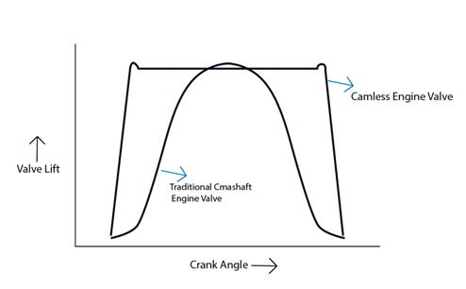

Figure ‎1.1: Valve lift vs crank angle

This can be seen from the above figure that the traditional camshaft engine valve mechanism have less area under the curve as compared to the cam-less engine valve mechanism supporting the argument that the cam-less engine valve mechanism will allow more air to come into the cylinder of engine as compared to the traditional camshaft engine valve mechanism and resulting in improved volumetric efficiency.

## Operation

* The IR sensor would read the crank angle
* This reading will serve as an input signal to Aurdino
* Aurdino will decide on this input of above signal whether to open the valve or close the valve
* When there is a signal to open the valve, the edge bridge will give the polarity to motor to rotate clockwise and thus open the valve. And when there is a signal to close the valve, edge bridge will reverse the polarity and motor will rotate anti-clockwise to close the valve
* This clockwise and anticlockwise rotation of motor will rotate the pinion attached to it
* After that this pinion will convert this rotatory motion into translational motion of rack and thus resulting in opening and closing of valve

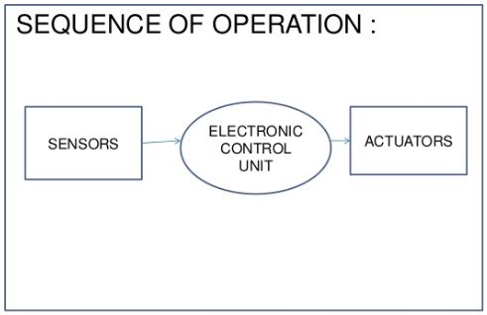

Figure ‎1.2 : Block diagram

## Prior Work:

Many companies are working to control the valves through some control system other than mechanical system. But none of them have implemented it yet. One of them who have made this type of actuator is freevalve (a sister company of Koenigsegg) in 2016. They have made an actuator hybrid of pneumatics and electronics. The actuator is well in performance. They are not implementing it because these actuators are very costly right now and they are working on reducing the expense of these actuators.

## Scope:

With the implementation of this project we will be able to

* Compact the engine as many of the components will be removed
* Reduce the friction losses
* Reduce the torque being wasted to drive the camshaft
* Reduce the emissions
* Have modern control system like we have in case of EFI system
* Have high power and efficiency according to requirement
* Turn off any cylinder of the engine when higher power is not required thus increasing the efficiency.

# LITERATURE REVIEW

Automotive sector is actually the biggest sector in the world. It consists of different companies which help in fabrication and designing of the automobiles. It is considered as world’s largest economic section by revenue. In 2007, according to surveys there were 805.7 million cars and light trucks on roads using for different purposes. These numbers of vehicles were consuming 975 billion L (liters) of petrol and diesel-fuel annually. The major source of transportation in the developed countries is automobile sector.

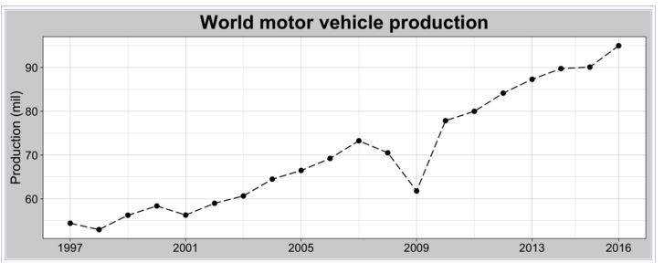

Figure ‎2.1 : Production of Vehicles

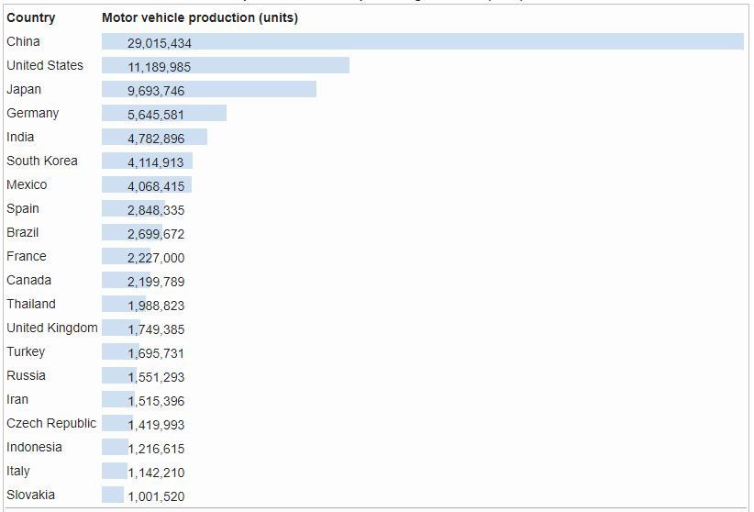

Figure ‎2.2 : Country-wise Production of Automobiles

We see a huge number of vehicles around us in form of railed vehicles, motor vehicles, aircrafts, watercrafts and generators. These vehicles help us in locomotion and if we see them in terms of generators then it help us in generation of power.

Automobile has now become the essential part of life in developed countries especially in Europe where people need vehicles to travel, go far off places for visiting and other purposes. Initially, the most cars in Europe were built by hands. Due to huge effort put to make only one car, they were sold highly expensive and only small number of people can afford them. The development of automobile industry was very rapid and it put huge effect on everyone. It is said that probably no other invention in the world has created much change than the development in the automobile industry.

In past, people do not have freedom to go far off places due to the hurdles. Then after the development of the automobile it gave people the freedom to move easily. The advance in technology, design and manufacturing has made the automobile safer than the past era. As everything has advantages and some disadvantages as the same time. The combustion in the engines causes the release of un-burnt hydrocarbons, nitrogen oxides and carbon monoxide. This result in polluting air and damaging health of crops and livestock. Automobile development is putting huge effect on people’s life in the world.

## Engines

A machine which is designed to convert one form of energy to another form of energy is called Engine. The engines about which we are concerned are Heat Engines. In heat engines, the fuel is burnt and the energy produced is used for doing useful work.

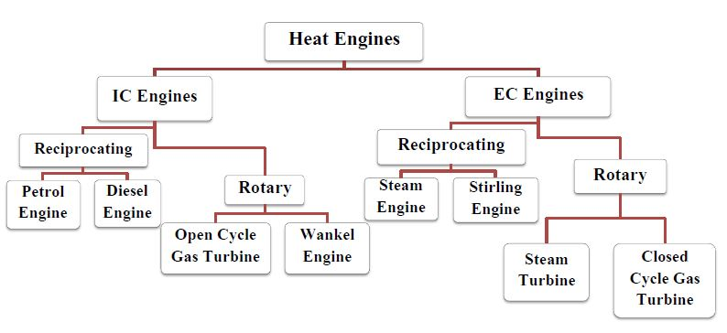

Figure ‎2.3 : Classification of Heat Engines

In Pakistan, the automotive industry is using mostly the following two engines:

* Diesel Engines (compression ignition)
* Petrol Engines (spark ignition).

## IC (internal combustion) engines

All petroleum and diesel Engines are called inner ignition motors and were intended to pack the blend of air and oil. This blend was combusted off by utilizing a sparkle (gas) or by compression (diesel).

In the internal combustion engines, the following is being done:

* The chemical energy in fuel is converted into mechanical energy by the combustion process.
* The energy produced is used in doing mechanical work.
* In actual, as the combustion occurs, the pressure and the temperature inside the cylinder increases.
* This output is usually taken on a rotating shaft.

There are some other applications which include driving pumps and generators, and some portable engines like lawn mowers chain saw. Now, some small engines are also in application for running of RC planes and small planes like them.

## Engines Classification on Basis of Ignition

Engines are the heart of any automobile. They can be divided into different groups on basis of different factors.

### Spark Ignition (SI)

In a spark ignition type engines, the spark plug is used. This spark plug gives high voltage between the two electrodes. This electrical discharge helps in igniting the air fuel blend. In old eras, the different forms of torch holes were used to ignites

### Compression Ignition (CI)

In this type of engines, the air fuel mixtures get self-ignite due to high compression in the engine. The temperature of the mixture is increased so high that the mixture self- ignites instead of the necessity of spark plug to start the ignition.

## Engines Classification on Basis of Engine Cycle

### Four-Stroke Cycle

The first and the mostly used type is 4 Stroke cycle. In four stroke cycle:

* The piston goes through two revolution
* There are four movements of piston ( Intake, compression, combustion and expansion)

### Two- Stroke Cycle:

In two stroke cycle there are:

* The piston goes through one revolution
* There are two movements of piston

## Engines Classification on Basis of Basic Design

### Reciprocating

Engine can have one or more cylinders in which pistons reciprocate back and forth. The combustion chamber is located in the closed end of each cylinder. Power is delivered to a rotating output crankshaft by mechanical linkage with the pistons.

### Rotary

Engine is made of a block (stator) built around a large non-concentric rotor and crankshaft. The combustion chambers are built into the non-rotating block.

## Engines Classification on Basis of Position and Number of Cylinders

### Single Cylinder

This type is mostly used in bikes where only one cylinder and one piston is present only.

### In-Line

In in-line, the cylinders are positioned in a totally straight line with one behind the other along the crankshaft of engine.The most common range of cylinders in In-line is 2 to 11. In-line four-cylinder engines are very common for automobile and other applications. In-line six and eight cylinders are historically common automobile engines. In-line engines are sometimes called **straight** (e.g., straight six or straight eight).

### V Engine

In this type, there are pairs of cylinders at some specific angle along the single crankshaft**.** The common angle ranges are15°-20°, with 60°-90°. V engines have even numbers of cylinders from 2 to 20 or more. V6s and V8s are common automobile engines, with V12s and V16s found in some high performance and comparatively luxury engines.

## Engines Classification on Basis of Air Intake Process

### Naturally Aspirated

In this type there is no intake air pressure boosts system.

### Supercharged

The intake pressure is increased with the help of compressor driven from the crankshaft.

### Turbocharged

In turbocharged, the air suction pressure is increased with help of turbine-compressor driven by crankshaft.

### Crankcase Compressed

Two-stroke cycle engine which uses the crankcase as the intake air compressor. Limited development work has also been done on design and construction of four-stroke cycle engines with crankcase compression.

## Engines Classification on Basis of Fuel Input methods:

* The basic method is the use of carburetor
* Fuel injection through the Throttle body
* Different number of fuel injectors can be used on each cylinder

## Different Fuels

* LPG
* Alcohol-Ethyl, Methyl
* Gas, Natural Gas, Methane.
* Gasoline
* Diesel and Fuel Oil

Dual Fuel:

A number of engines are present in the market that works on dual fuel nature. There are some large IC engines, which use a package that consists on diesel and CH 4. The heavy cost of diesel fuel cause it to be not suitable in poor countries. They are being used as an alternative to straight diesel or petrol engines in the market.

**Gasohol:** The most commonly used fuel consists of:

* Ten percent alcohol and Ninty percent gasoline.

## Air and Fuel Induction:

### Intake System

As the engines run on fuel. And for better burning efficiency proper air and fuel mixing is important, which is done by the intake system. The main objective of this intake system is to give the proper mixing of air and fuel, direct the air and fuel mixture to the cylinders of the engine and inject them at proper time into the cylinders of the engine so that maximum combustion and volumetric efficiency can be achieved.

The overall intake system consists of

* **Intake manifold**: which guides the air-fuel mixture to flow towards the cylinder
* **Throttle body:** which controls the intake of the air
* **Intake valves** which opens to allow the air-fuel mixture to come into the cylinder
* **Fuel injectors or carburetors** which are used to add fuel.

### Carburetors

Carburetors has been used to inject the fuel into air to give a controlled air-fuel mixture to engine of the automobiles for several decades. But as the world in finding ways to save the fuel so research centers has been working to make the better control over the fuel intake to the engine, so by the 1980s the carburetors were replaced by electronic fuel injectors which are more compact, more controlled and more sophisticated. But the fuel injectors requires more costly control systems. Although many cars, airplanes and lawn movers still use carburetor engines because they are a bit cheaper than the modern fuel injectors. Although many of these carburetors are being replaced by fuel injection systems because the pollution laws are becoming more strict.

The basic working principle of carburetor is very simple. The basic carburetor is a venturi tube (A) which is mounted with a throttle plate (B) and a capillary tube to input fuel (C) which operates on the venture effect. A simple carburetor is shown in the figure. The carburetor is located before the intake manifold. Usually there is an air filter before the carburetor to filter the air coming into the carburetor. The other main components of carburetors include the fuel reservoir (D), main metering needle valve (E), idle speed adjustment (F), idle valve (G), and choke (H).

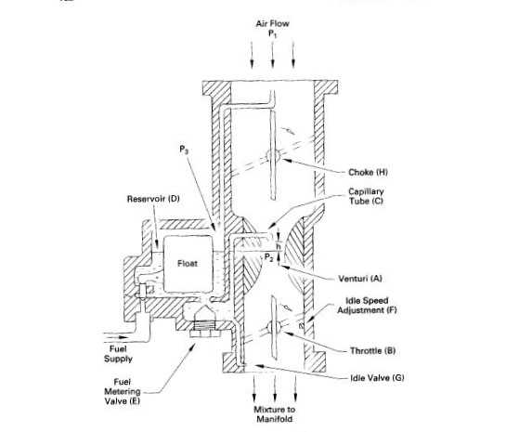

Figure ‎2.4 : Schematics of Carburetor

### Working Principle of carburetor

As the air flows into the engine due to pressure difference in the surrounding atmosphere and a vacuum into the cylinders during the intake stroke, the air accelerated at the venturi duct due to sudden reduction in the area (continuity theorem). As the velocity of the air is increased, then according to Bernoulli’s theorem it results in the reduction of pressure below the atmospheric pressure in the vicinity of that air. The pressure of the fuel in the reservoir is equal to atmospheric pressure as it is vented to the atmosphere. And this creates a pressure difference into the fuel supply capillary tube, which then as a result forces the fuel in the reservoir tank to flow into the capillary throat. When this fuel approaches in the venturi throat it divides into small droplets and mixes with the air. Then fuel evaporates during its way towards the intake manifold. As the speed of engine is increased, more air enters into the carburetor with more speed, when this air passes through venturi throat with higher speed, it results in more pressure difference at the throat which increases the flow of fuel to meet the engine needs.

Fuel injectors are nozzles that inject a spray of fuel into the intake air. They are normally controlled electronically, but mechanically controlled injectors which are cam actuated also exist. A metered amount of fuel is trapped in the nozzle end of the injector, and a high pressure is applied to it, usually by a mechanical compression process of some kind. At the proper time, the nozzle is opened and the fuel is sprayed into the surrounding air.

Most modern automobile SI engines have multipoint port fuel injectors. In this type of system, one or more injectors are mounted by the intake valve(s) of each cylinder. They spray fuel into the region directly behind the intake valve, sometimes directly onto the back of the valve face.

### Intake valves

An engine is essentially a large air pump. More power can be created through combustion if more air is sucked and mixed with fuel. So, the engine can manage power in better way if it removes the exhaust gases efficiently. The adequate passage of gases from one end to other is the key to a strong and healthy engine.

Different components affects the air flow into the engine, but the amount of air entering into the cylinder and the volume of exhaust gases leaving it is mainly controlled by the valves placed into the head of the engine. The intake valves open up just before the combustion which allows the air to flow in and mix with fuel, and the exhaust valves open after the ignition of this mixture in order to suck out the resulting gases. A rotating shaft controls the timing of the engine which is called the camshaft. The lobes on the camshaft push up on the valves in order to open them and drop them back closed again with the help of a spring system.  
  
The duration for which the valves remain open, and at what point they will open in the combustion cycle, can have a big impact on the drivability and power generated by an engine. For example, if in case of racing cars you need greater power at higher RPMs. Camshaft can be adjusted to perform well at higher RPMs. This will in result lower the performance at lower RPMs, which is OK with a race car. Conversely, if you need a lot of low-end torque - which is greatly used for towing – camshaft must be adjusted to perform well at lower RPMs. But this will again affects the performance at higher RPMs.

Street vehicles are a compromise between reliability, fuel efficiency and power. While the engines of race vehicles have camshaft designs that generate large amounts of power only at specific, high revolutions. But our daily driver encounters a wide range of RPMs so a broader power band is necessary for that. While it is ok for a race car to have a lumpy idle that barely runs below 1000 rpm, it would do you no good if your street car stalled out at every stoplight. Regular vehicles usually need a camshaft that gives a wide range of high power at a wide range of RPMs.

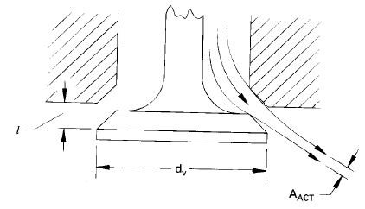Most of the internal combustion engines have poppet valves that are spring loaded i.e., they are pushed to open at proper time in the engine operating cycle by the engine camshaft. These valves are opened by compressing the spring attached between the engine head and one side of the valve. These valves are retracted back by the restoring force of the spring and are perfectly closed under that restoring force. The spring closes the valve with enough force to prevent any sort of leakage. A number of engines also use sleeve valves or rotary valves. A schematic of valve is shown in the figure.

Figure ‎2.5 : Schematics of Valve

The material of most of the valves and the seat on which they close are made up of hard alloy steel and in some cases it is made up of ceramics. These valves are connected to the camshafts through some sort of linkages. Ideally, the valves of engine must open and close instantly at the proper time. But in real it is not possible to operate the valves instantly through mechanical linkages because they results in increased wear, noise and some undesired vibrations in the mechanism. Camshaft have lobes on it which are designed to give a quick but smooth opening and closing of valve. But to have this smooth actuation of the mechanism we have to compromise on the actuation speed of the valve.

In the early engines the camshafts were placed far away from the engine valves i.e., the valves were mounted in the engine head while camshafts were mounted in the engine block. As the automotive technology enhanced the valves were shifted to cylinder head to reduce the mechanical components like push rods, rocker arms and tappets. They are called overhead valves. Then this was improved further by moving the camshafts to the engine head. Many of the modern engines have one or two camshafts mounted in their engine head. This type of engines are called overhead cam engines. If there is single camshaft in overhead cam engine then this type of engine is called SOHC (Single overhead cam) engine. SOHC engine is shown below:

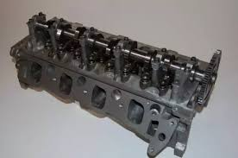

Figure ‎2.6 : Single overhead cam engine

And if there are two camshaft in overhead cam engine then this type of engine is called DOHC (Double overhead cam) engine. A double overhead cam engine is shown below:

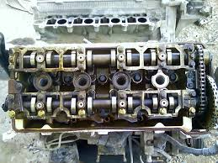

Figure ‎2.7 : Double overhead cam engine

The closer is the camshaft installed to the valves the lesser will be the losses due to mechanical linkages and hence higher would be the efficiency of the engine. The distance that the valve covers during its opening is called valve lift and usually it is order of few millimeters depending on the size of the engine.

The shape, area and angle of the valve designed specifically to give more flow area to the flow of fluid and give maximum mixing of air-fuel mixture, which results in increased efficiency of overall engine.

Usually intake valves gives very much restriction to the air coming into the cylinder and hence decrease the volumetric efficiency of the engine.

So researchers focused to search for the minimum area of valve required. They ended up a formula that gives the minimum valve area that is required in the modern engines. That formula is

$Ai=CB^{2}\left[\frac{\left(Up\right)max}{ci}\right]=\left(\frac{π}{4}\right){d_{v}}^{2}$ (1)

Where:

C = Constant having a value of 1.3

B = Bore

(Up) max = Average piston speed at maximum engine speed

ci = Speed of sound at inlet conditions

dv = Diameter of valve

Ai = Total inlet area of the valve whether it has one two or three valves

On many newer engines with overhead valves and small fast-burn combustion chambers, wall space in the combustion chamber is less to fit the spark plug and exhaust valve and still have room for an intake valve large enough to satisfy the equation (1). That’s why, more than one intake valves per cylinder are built now in most of the new engines. Two or three smaller intake valves give greater flow area and less flow resistance as compared to one larger valve, as was used in older engines.

At the same time, these two or three intake valves, along with usually two exhaust valves, can be better fit into a given cylinder head size with enough clearance to maintain the required structural strength. This type of valves are shown in the figure

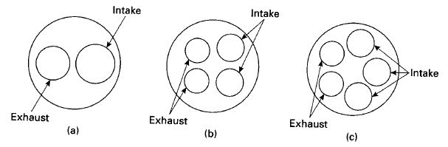

Figure ‎2.8: Valve arrangements for different modern

Multiple valves enhances the complexity of design which requires more camshafts and mechanical linkages to operate the valves. Sometimes it is necessary to have specially shaped cylinder heads and recessed piston faces which is to avoid valve-to-valve or valve-to-piston contact. The valves will be smaller and lighter, when two or more valves are used instead of one. This results in the use of lighter springs and also reduces forces in the linkage. These lighter valves can also be opened and closed faster and this overshadows the added cost of manufacturing and the added complexity and mechanical inefficiency can be justified with greater volumetric efficiency of multiple valves.

Some engines with multiple intake valves are designed such that at lower speed only one intake valve per cylinder is operated thus reducing the air fuel mixture entering in the cylinder at lower speeds. At higher speeds, less real time per cycle is available for air to come into the cylinder, and the second (and sometimes third) valve actuates, giving additional inlet flow area and thus increasing the flow of air fuel mixture. This gives enhanced control of the flow of air within the cylinder at different speeds, which gives us more efficient combustion. In some of these systems, the valves will have different timing. The low-speed valve will close at a relatively early point aBDC. When operating, the high-speed valve(s) will then close at a later position (up to 20° later) to avoid lowering the volumetric efficiency.

## Valve Timing

Valve timing is actually the accurate timing of the opening and closing of the inlet and exhaust valve. This term is usually used in the engines which have pistons in them. In the internal combustion engines of automobiles, poppet vales are used whose timing is controlled by camshaft.

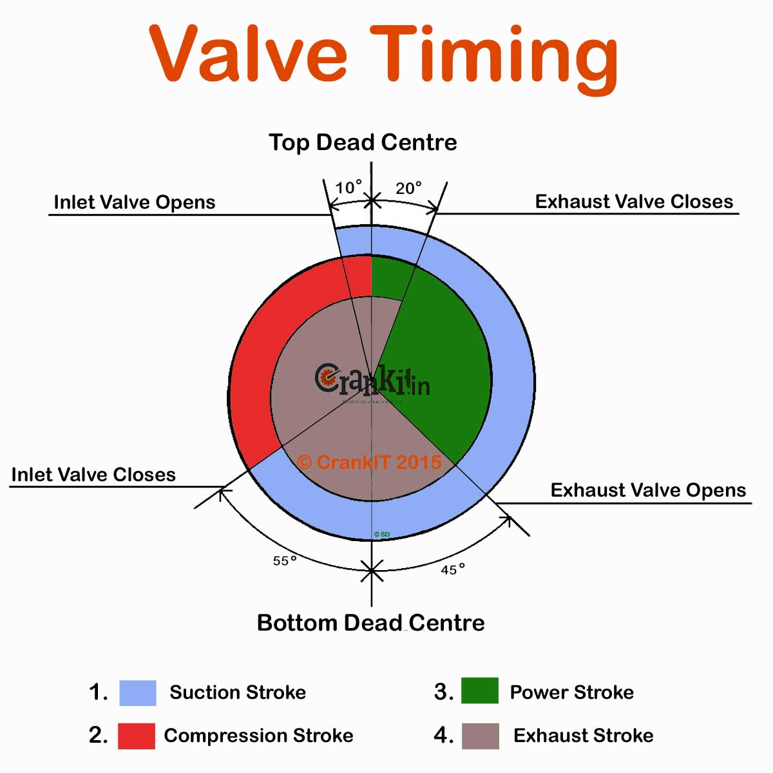

Figure ‎2.9: Valve timing chart

Intake_valves_normally_start_to_open_somewhere_between_10°_and_25°_bTDC_and_should_be_totally_open_by_TDC_to_get_maximum_flow_during_the_intake_stroke.

The_higher_the_speed_for_which_the_engine_is_designed,_the_earlier_in_the_cycle_the_intake_valve_will_be_opened._In_most_engines_valve_timing_is_set_for_one_engine_speed,_with_losses_occurring_at_any_lower_speed_or_higher_speed._At_lower_than_design_speed_the_intake_valve_opens_too_early,_creating_valve_overlap_that_is_larger_than_necessary._This_problem_is_made_worse_because_low_engine_speeds_generally_have_low_intake_manifold_pressures._At_higher_than_design_speeds,_the_intake_valve_opens_too_late_and_intake_flow_has_not_been_fully_established_at_TDC,_with_a_loss_in_volumetric_efficiency.

Automobile_engines_operate_at_many_different_speeds,_with_valve_timing_set_for_optimization_at_only_one_speed._Industrial_engines_which_operate_at_only_one_speed_can_obviously_have_their_valve_timing_set_for_that_speed._Modern_automobile_engines_have_longer_valve_overlap_because_of_their_higher_operating_speeds.

Intake_valves_normally_finish_closing_about_40°-50°_aBDC_for_engines_operating_on_an_Otto_cycle._Again,_the_correct_point_of_closing_can_be_designed_for_only_one_engine_speed,_with_increased_losses_at_either_higher_or_lower_than_design_speed.

## Variable Valve Timings

Various_ways_of_obtaining_variable_valve_timing_are_being_developed_for_automobile_engines._These_allow_intake_valve_opening_and_closing_to_change_with_engine_speed,_giving_better_flow_efficiency_over_a_range_of_speeds._Some_engines_use_a_hydraulic-mechanical_system_that_allows_for_an_adjustment_in_the_linkage_between_the_camshaft_and_valves._It_does_this_with_engine_oil_and_bleed_holes_that_require_longer_cycle_time_(equal_real_time)_to_shift_linkage_dimensions_as_speed_is_increased.

With_proper_design,_the_intake_valve_can_be_made_to_open_earlier_and_close_later_as_engine_speed_is_increased.

Some_engines_have_camshafts_with_dual_lobes_for_each_valve._As_engine_speed_changes,_the_follower_that_rides_the_cam_shifts_from_one_lobe_to_the_other,_changing_valve_timing._This_gives_better_engine_efficiency_at_a_cost_of_mechanical_complexity_and_added_cost.

The_most_flexible_variable_valve-timing_system_is_electronic_actuators_on_each_valve_and_no_camshaft._This_has_been_done_experimentally_on_engines_but_at_present_is_too_costly_and_takes_up_too_much_room_to_be_practical_on_automobiles._Not_only_does_this_type_of_system_give_essentially_infinite_variation_in_timing,_but_it_also_allows_for_changing_valve_lift_and_gives_much_faster_opening_and_closing_times_than_that_which_can_be_obtained_with_a_camshaft.

If_valve_lift_can_be_controlled,_more_efficient_operation_can_be_obtained_at_all_engines_speeds._Flow_resistance_and_mass_flow_patterns_can_be_changed_to_better_give_desired_operation_characteristics_at_different_speeds._Some_variable_valve_timing_operations_being_used_in_the_automobile_industry_of_Pakistan_are_discussed_as_under:

### VVT-I

In VVT-I, the ECU of the automobile gets signals from different sensors. These include:

* Camshaft Position Sensor
* Mass Air Flow Sensor
* Engine Coolant Temperature Sensor
* Oil Temperature Sensor
* Crankshaft Sensor

This information is used as an input to a valve which is actually a oil control valve. This valve, according to the information given, acts an actuator. This actuator helps in rotating the rotor. This rotor is actually connected to the camshaft. This all is further connected to the covering. Now, as we know that crankshaft is connected to camshaft through a chain which is known as Timing Chain. So the process is break down as following:

* The ECU keeps on receiving signals from the specific signals.
* The difference between the crankshaft angle and optimum angle is used as a signal.
* This signal helps in moving the hydraulic valve and thus the valve timing is controlled.

A schematic of vvti mechanism is shown below:

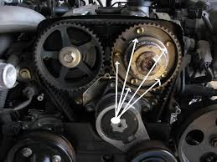

Figure ‎2.10 : VVTI

### VTEC

Camshafts in this type of mechanism have two different sizes of lobes. At lower speed and lower power requirements the lobe of smaller size is operated. In this system when the vehicle crosses specific rpm and require higher power ECU gets signal to operate lobe with max lift. In this system, two lobes have same size while the third one which is present in between the other two has higher lift. This is done by operating the spool valve. Spool valves throws jet of oil on the piston located on the rocker arm. This jet of oil provides enough force to move the piston and lock the rocker arm which results in operation of higher size lobe.

A schematic of camshaft being used in VTEC technology is shown below:

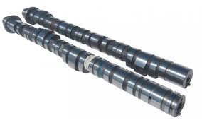

Figure ‎2.11 : Camshaft with variable sized lobes

## Actuation of valves affecting volumetric efficiency

It is desirable to have maximum volumetric efficiency in the intake of any engine. This will vary with engine speed. Figure below represents the efficiency curve of a typical engine. There will be a certain engine speed at which the volumetric efficiency is maximum, decreasing at both higher and lower speeds. There are many physical and operating variables that shape this curve.

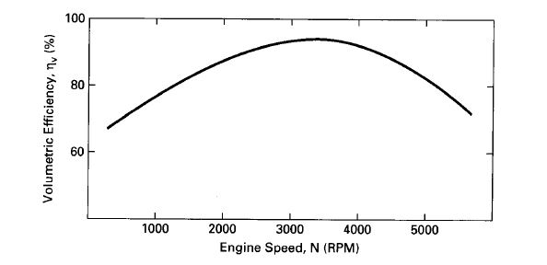

Figure ‎2.12: Volumetric Efficiency vs Engine Speed

Below is a list of factors affecting volumetric efficiency

### Fuel Injection:

The Volumetric efficiency depends upon the following:

* Which fuel is being used
* When fuel is being added
* How Fuel is being injected

As we know that volumetric efficiency is always less than the Hundred percent. The reason being, the blend also contains some fuel while combustion is done. This fuel evaporates and makes the efficiency less than 100 percent.

In some engines, the air fuel mixture is added to the cylinder through the use of a carburetor or a throttle body. These automobile engines have less efficiency because as the fuel is added to air, the fuel definitely will evaporate as the process goes on.

The second method is the use of advanced technology which is the use of Multiport Injectors. In these systems, the air is not displaced while the fuel is added directly to cylinders. Thus, making this more efficient.

There could be more possibilities of increasing the efficiency by introducing different kinds of fuel through different process which cause less evaporation as compared to the recent fuel intake processes.

### Valve Overlap

Valve overlapping affects the volumetric efficiency. This happens through the following procedure:

* When the piston is at the Top Dead Center in the cylinder during the end of exhaust stroke (4th stroke), the inlet and exhaust both valves remain open for some time.
* This causes the decrease in the volumetric efficiency because some of the exhaust gases come back to the cylinder.
* The air-fuel blend which is coming through the inlet valve is actually replaced and thus the volumetric the volumetric efficiency is reduced.

### Closing Intake Valve After BDC

The closing of the intake valve is very important factor in the automobile cycle. They affect the volumetric efficiency.

When the piston is at the start of the cycle, during suction phase, it is coming from top to the bottom dead center. The pressure inside the cylinder gets low and the pressure outside the cylinder is atmospheric. A pressure difference is created. This pressure causes the air to enter from outside the cylinder to inside it.

This process keeps on occurring until the pressure that is developed internally becomes equal to the atmospheric pressure. The volumetric efficiency will decrease:

* If the intake valve is closed before bottom dead center, sufficient air would not enter and thus causing decrease in volumetric efficiency.
* If the intake valve is closed after the bottom dead center, still the air which is being compressed reverses back the incoming air and thus decreasing the efficiency.

Thus the valve timing is very important and a compromise is made in large range operating speed engines. And the engines are designed for an optimum speed.

We used (Pullark, 1997), (Heywood, 1988) and others mentioned in bibliography table.

# ENGINE SELECTION

## V-4 Engine

The implementation of the cam-less mechanism was first of all tried on large engines like V-4 engines. A simple V-4 engine is shown below:

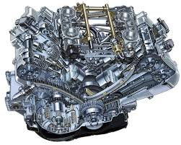

Figure ‎3.1: V-4 Engine

The following are the reasons for not choosing this for our project:

* The financial cost of a V-4 engine was out of range.
* Any project is implemented firstly on the smaller scale to check its feasibility so we looked for smaller engine instead of V-4.
* Due to high design complexity we chose smaller engine.
* If it can be done implemented on one cylinder then it can be implemented on V-4 as well.

## Glow Engines

After the V-4 engine, we looked for the glow engines. The simple glow engine is as follow:

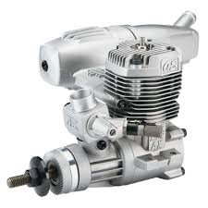

Figure ‎3.2 : Simple Glow Engine

The following are the reasons for not choosing glow engines:

* Too much compactness
* No place for installation of sensors and mechanism mounting.
* The high financial cost.
* The high Rpm’s of glow engines making it un-suitable for our cam-less mechanism.
* High Rpm’s motor for mechanism were not available in market.

## 20-30 CC Engine

These engines are used in lawn mowers and other purposes. They are shown below:

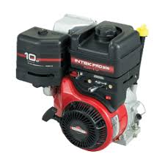

Figure ‎3.3 : CC lawn Mower

Reasons for not selecting 20 CC for implementation of Cam-less mechanism are as follow:

* High Rpm’s require motor of very high Rpm’s for the cam-less mechanism.
* The high Rpm’s motors were very expensive and not available in market.
* These engines were not suitable for mounting of mechanism due to small engine size.

## 50 CC Engine

The 50 CC engines looked suitable after the glow engines. The 50 CC engine is as shown below:

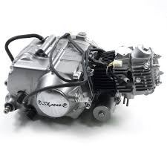

Figure ‎3.4 : A typical 50 CC Engine

Following are the reasons for not choosing 50 CC engine:

* 50 CC were not available easy in the market.
* 50 CC and 70 CC were of almost same size so instead of buying new 50 CC, we preferred using 70 CC which was easily available in our laboratory.

## 70 CC Engine

After all the market research, we found 70 CC suitable for our project. The 70 CC engine is shown below:

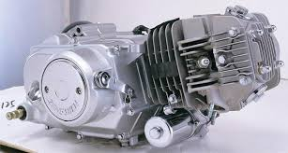

Figure ‎3.5: 70 CC Engine

### Reasons for selecting 70 CC

* 70 CC was easily available in our lab.
* There was only low expense required for its tuning.
* 70 CC has enough space for installation of sensors and mounting of mechanism.
* We found the data of 70 CC easily as compared to smaller engines.

# ACTUATION METHODS

## Actuation Methods

In order to power valves there were several methods available to propel the mechanism. Here is some review about the available methods and how we made our choice.

### Hydraulic

Hydraulic system uses a pressurized fluid to propel the mechanism. It involves use of a piston cylinder arrangement to run mechanisms. This Actuation method is characterized by the very famous “Pascal’s law”

Pascal says that pressure on every surface in a closed system is equal, but the amount of exerted by it varies with respect to area of cross section.

$$P_{1}= P_{2}$$

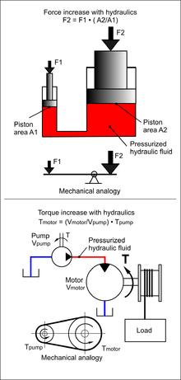Hydraulic valves are classified on the basis of their use and operation method.

Figure ‎4.1: Pascal's Law Concept Diagram

* Classification based on function:
* Pressure control valves (PC Valves)
* Flow control valves (FC Valves)
* Direction control valves (DC Valves)
* Classification based on method of activation:
* Directly operated valve
* Pilot operated valve
* Manually operated valve
* Electrically actuated valve
* Open control valve
* Servo controlled valves
* Manifold

Hydraulically controlled valves are known to be slower in response. Due to this their application is limited to the systems that require high power, low speed and sometimes less precision.

### Pneumatic

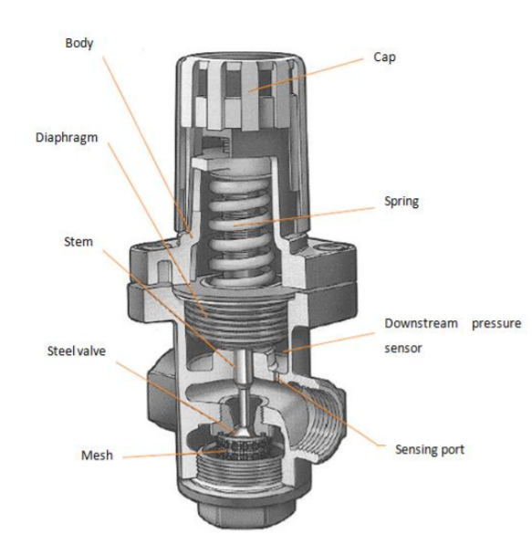Pneumatic systems like hydraulic system also require control valves to direct and regulate the flow of fluid from the compressor to the various devices like air actuators and air motors. In order to control the movement of air actuators, compressed air has to be regulated, controlled and reversed with a predetermined sequence. Pressure and flow rates of the compressed air to be controlled to obtain the desired level of force and speed of air actuators.

Figure ‎4.2 : Three dimensional figure of pressure regulating valve

Pneumatic valves can be designed to operate very complex systems with precision but these systems require a reservoir pressurized to high temperature.

Valves are also classified on the basics of their operation and controlling system.

### Electronic

Electronic actuators available both in rotary and linear motion format. On the basis of motion actuators are classified as:

* Linear Actuators
  + 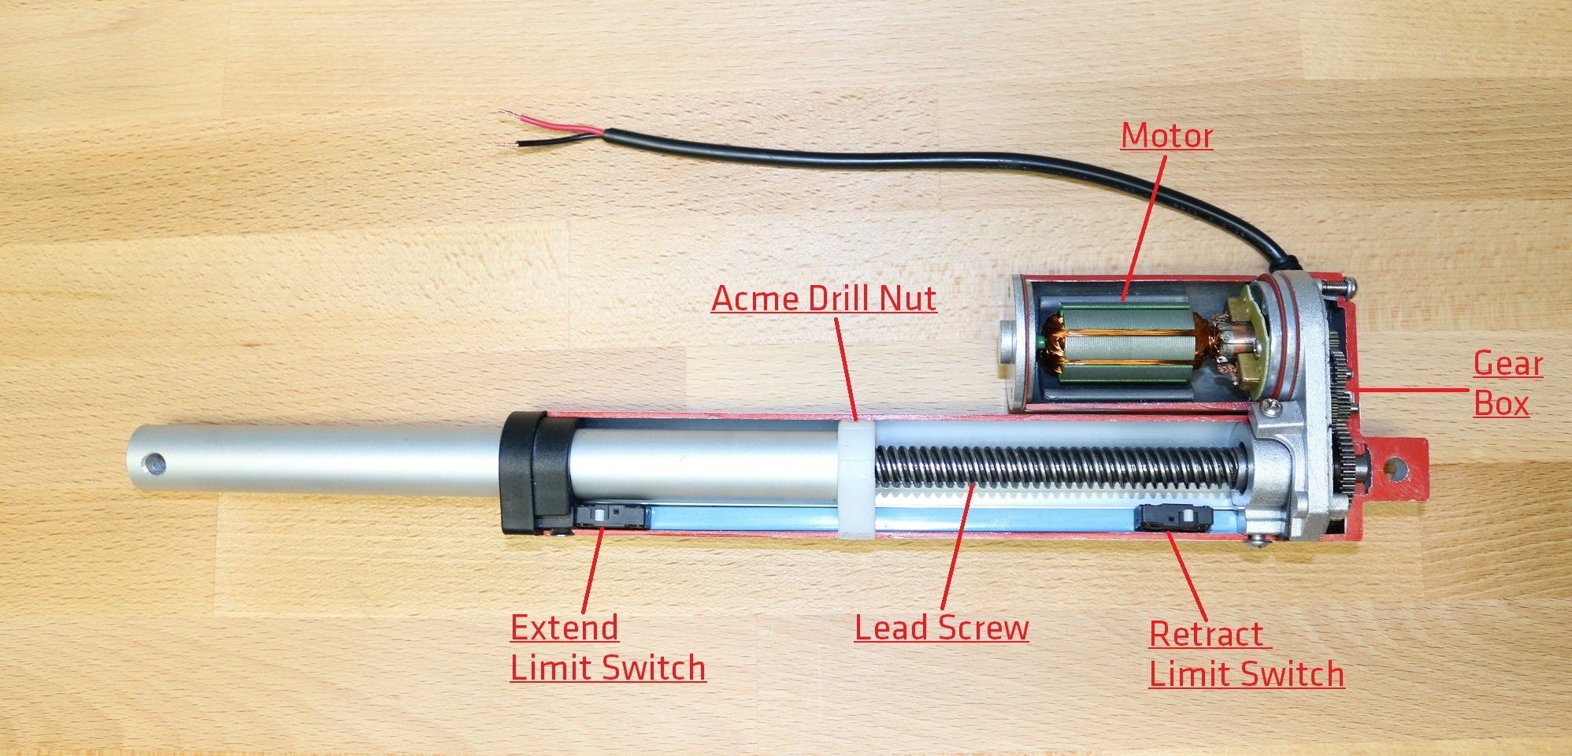Linear motion actuation according to given instruction using a some micro controller.

Figure ‎4.3: An Electronic Linear Actuator

* Rotary Actuators
  + Rotary actuators are actually motors. Motors are classified in various types as follows:
    - DC motors
    - Servo DC motors
    - Stepper DC motors
    - AC motors
    - AC Induction motor

Etc.

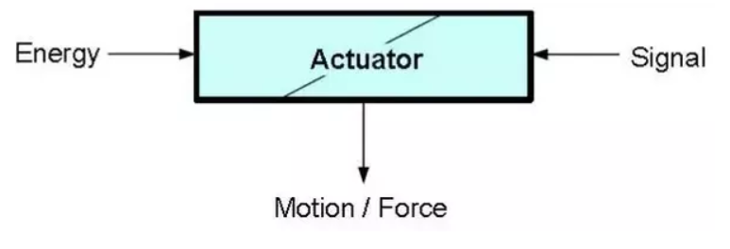

Figure ‎4.4 : Actuator Block Diagram

Linear actuators can be directly attached to the part which is desired in linear motion. In case of rotary actuators, there are some mechanism available to transform the rotary motion into linear motion. Few of these are:

* Rack & Pinion
* Four bar mechanism arrangement
  + Crank slider mechanism

etc.

### Hybrid

Hybrid methods use a combination of above all to operate the system. These specific are used when some specific torque/power and time rated systems are to be developed. These methods offer a variety of variable combinations. When combined with microcontrollers, these methods provide countless options to actuate the system.

For example hybrid linear actuators are perfect for use where high thrust is required with small position changes.

Electronic pneumatic actuators like servo pneumatic actuator and electronic hydraulic actuators are very popular. For example an electrically operated pneumatic valve can be closed and opened using instructions given to a motor attached to a butterfly valve.

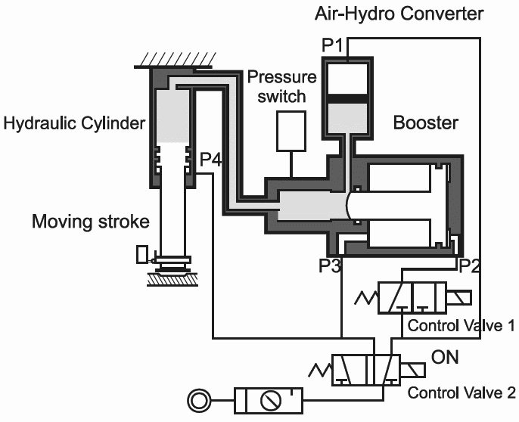Some systems use hydro pneumatic arrangement to operate the system. For example in following picture the valve is using pneumatic pressure to boost the valve operation.

Figure .: Hydro Pneumatic Valve Concept Diagram

## Brief Analysis

In order to select the Actuation method for our valve operation we had to do some basic analysis. In this brief analysis we determined the torque, time of operation and speed of operation with respect the selected threshold RPM we are going to operate engine on.

## Power Method Selection

After initial brief analysis at threshold values of engine RPM we determined that we can use a pneumatic or electronic or some hybrid Actuation for our valve.

### Pneumatic

We had a piston valve of available of *10mm* diameter piston and to power that valve on exhaust valve we needed a very big reservoir which was out bounds of our financial constraints.

### Hybrid

Hybrid systems at this level of compactness are not available in Pakistan. Their market is nonexistent. Some companies like Tetrapack use these systems which they have developed by themselves. Most of these industrial hybrid systems are patented to these companies and are not available in market.

### Electronic Actuators

We selected electronic actuators to run our mechanism. Initially linear actuators were proposed but they had very low power ratings. After a detailed market survey over electronic actuators we decided to use DC servo motor for our mechanism. DC servo motor is coupled with Actuation mechanism to provide required operation of engine valve.

## Mechanisms

### Crank Slider Mechanism

Crank slider is a conventional method in mechanics used to convert rotary motion into linear motion. It has mechanics of a four bar mechanism. Crank when rotated through some amount of angle gives a relative linear motion to slider. Slider in our case can then power the valve and provide us with required operation. This kind of arrangement already exists in engine that is the piston cylinder arrangement.

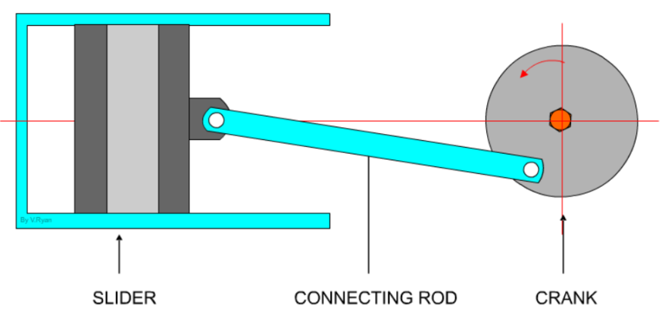

Figure .: Crank Slider Mechanism

### Push rod and Cam

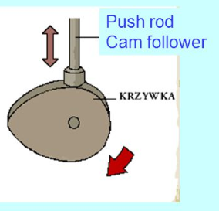In push rod and cam combination, the cam follower mechanism can be used to provide the motion. A rotating for a specific linear motion can provide the motor driven valve operation. Profile of cam determines the push rod position vs time graph.

Figure .: Push rod and Cam Design

### Independent Cams for each valve

In order to control the time graph independent of crank shaft angle, cam-shaft can also be motor driven and its speed and motion graph can be controlled using complex data graphs required to maintain best engine operation.

Now operating the already mounted camshaft will make not much difference and little improvement can be achieved by giving valve position data with respect to micro seconds of time.

If both valves are operated by two separate motors, we can have independent motions. We can vary timings of each valve with respect to crank shaft angle and RPM of engine. In this case both valves will not be dependent on each other and we can increase or decrease timing of one valve independent of other.

Independent cams can just not only maintain valve timings but can also be used to control valve lift if operated discontinuously. Instead of constantly rotating cam in one direction to move valve back and forth due cam profile, we can give algorithm to operate cam in both cloak and anticlockwise direction. In later case, cam profile will be a little different. 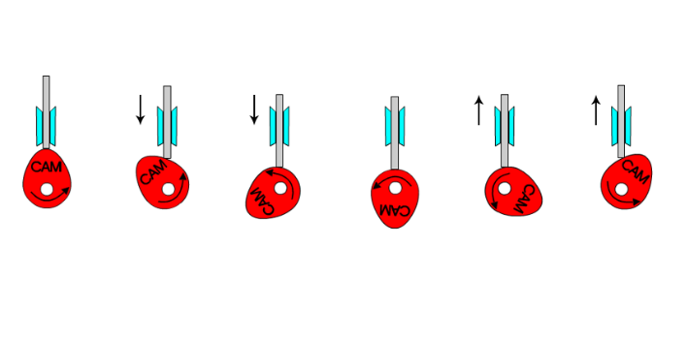

Figure .: Continuous Unidirectional Cam Rotation

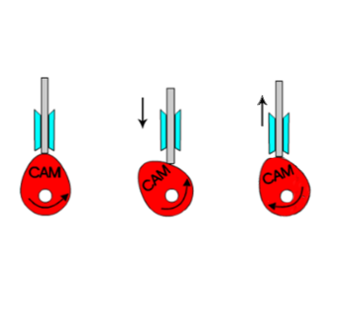

Figure .: Discontinuous Two Directional Cam Motion

### Rack & Pinion

Rack and pinion is a mesh of two gears. One gear has round shaped with teeth on its circumference and the other one is a bar with teeth on one surface.

Rotatory motion of pinion gives linear motion to rack. Rack can directly be attached with valve and required motion profile and varying timing with respect to engine RPM can be achieved.

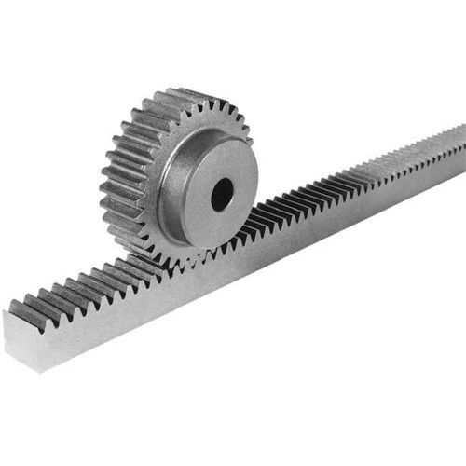

Figure .: Rack and Pinion Gear System

## Mechanism Selection

### Crank Slider Mechanism

Crank slider mechanism is not used because the velocities achieved are variable over the motion of motor. It creates ambiguities in linear motion achieved with respect to input crank rotation.

We also had manufacturing constraints of market because achieving the most precise mechanism is necessary.

Last but not least, this mechanism is not very compact to manage and maintain after installation on engine.

### Rack and Cam

Rack and cam have a very basic limitation. Cam has a permanent profile and it limits the amount of variations in valve timings and valve lift. A number of possibilities can still be achieved but it’s the perfect model.

### Independent Cams for each valve

Independent cams do provide variable timing and lift and independent intake and exhaust valve operation. It still can’t completely be a variable and swift system to achieve the maximum results.

### Rack & Pinion

Rack and pinion offers the maximum variation and we choose it because:

* It can provide both quick and slow mechanism operations.
* It offers compactness more than any other mechanism in our case.
* Its fabrication is easily available and financially viable.

## Final Selected Mechanism and Actuation Method

As I have already stated that we selected rotary actuator that is, a motor. Selected mechanism is rack and pinion arrangement.

Motor will drive the pinion and the motion profile is based on a given position vs time value graph. Time calculated using the RPM and required respective crank angle engine.

A generic arrangement is here:

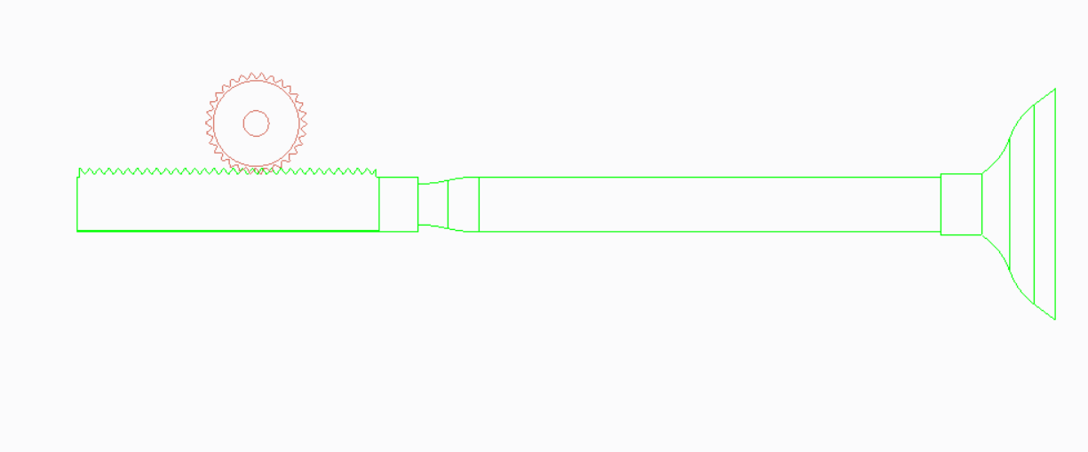

Figure .: Finalized Concept

# MECHANICAL DESIGN AND ANALYSIS

## Concept Block Diagram

After having decided that how we are going to propel valve and what mechanism we are going to use to make the project, we proceeded with report.

Following are the factors which are going to play crucial role in valve operation:

* Crank Position
* RPM
* Actuator(Motor)
* Microcontroller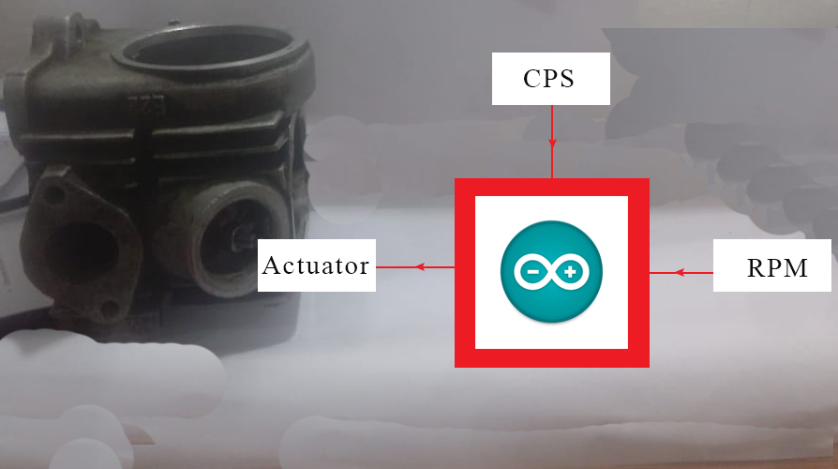

Figure .: Concept Block Diagram

### Crank Position & Crank Position Sensor (CPS)

It is measured in degrees of angle. Crank position angle is given as reference in available data sheets which tell us for how much angle rotation of crank shaft, valve is going to open.

Crank position sensor will measure the live angle values of engine and feed these values to microcontroller.

## Acquired Data

As we are using an already available data so we experimentally calculated data of engine which as show as follows:

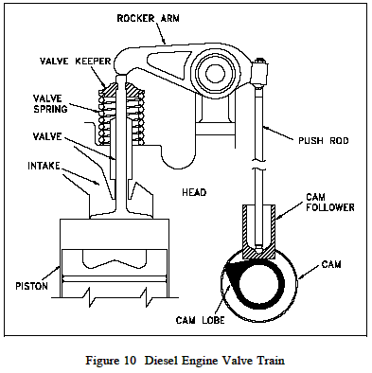

Figure .: Valve assembly in 2D

|  |  |  |  |
| --- | --- | --- | --- |
| Entity | Symbol | Unit | Value |
| Maximum pressure at exhaust valve | Pe | bar | 2-2.5 bar |
| Maximum pressure at intake valve | Pi | bar | Atmospheric or less |
| Engine stroke | S | mm | 41.4 |
| Engine bore | B | mm | 47 |
| Spring constant of already installed spring | Ki | Nm | 26000 |
| Spring preload | xo | mm | 2 |
| Valve lift | x | mm | 5 |
| Intake valve diameter face diameter | di | mm | 20 |
| Exhaust valve diameter face diameter | do | mm | 25 |
| Surface area of intake valve face | Ai | mm2 | 314 |
| Surface area of exhaust valve face | Ao | mm2 | 490.625 |

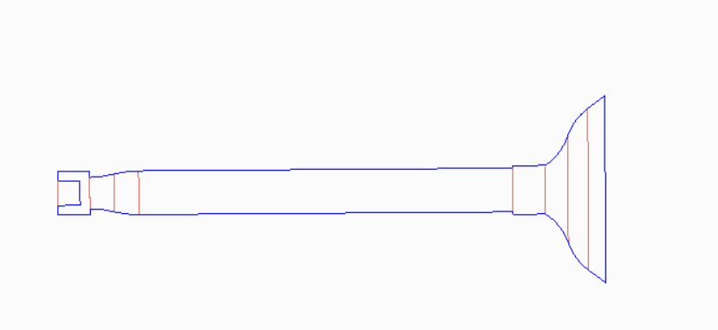

di or do

Figure .: Engine valve

Using the following equation surface area of valve face is calculated on which intake and exhaust pressures act.

$A=πr^{2}$ (1)

A: surface area of valve face

r: radius of valve (d/2)

## Manual Calculations for Mechanism

All the valve operation timings are related with crank angle and to

$t=π\frac{a^{o}}{{12RPM}_{c}}$ (2)

t: time

ao: angle in degrees

RPMc: Crank Rotation per minute.

Now for example, if valve is required to open and close by the time crank shaft rotates through an angle of 235o, the time for valve at 750 RPMc turns out to be 0.04 seconds.

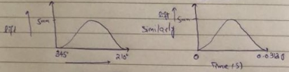

*Figure ‎5.4*: Valve lift vs crank angle and valve lift vs calculate time

## Simulated Excel Model

We developed a simulation model on excel to find the valve timings and actuator credentials.

### Engine Design Parameters Based Simulation

Firstly we tried calculating the actual lift that engine should have according to its design. We had literature research for it from (Ganesen, 2003). This gave us following results.

Following table has generated lift according to design and given required linear force for actuator to run the operation:

All values are in SI units except mentioned otherwise:

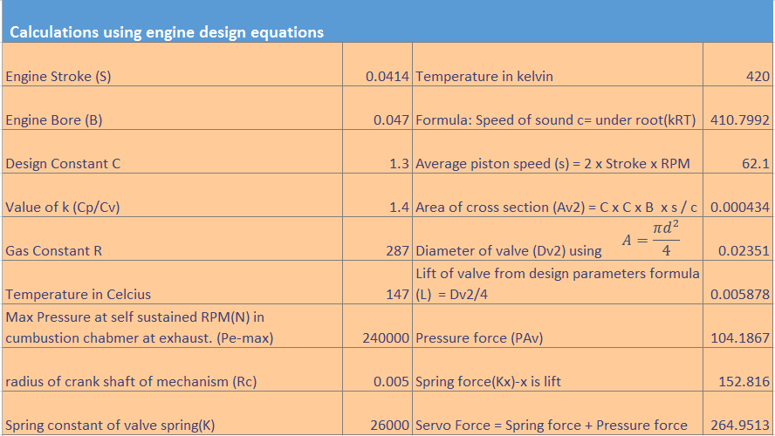

Figure .: Calculations using Engine Design Parameter

After getting the lift according to design parameters, we calculated the RPM required to rotate pinion so that it gives the linear motion to rack equal to lift in the time calculated using crank angle and RPM of engine in previous table.

In below table valve lift is compared with circumference of pinion and angle for that amount is calculated as shown in third last row. This angle is later divided by 70% of total operation time to calculate the pinion RPM.

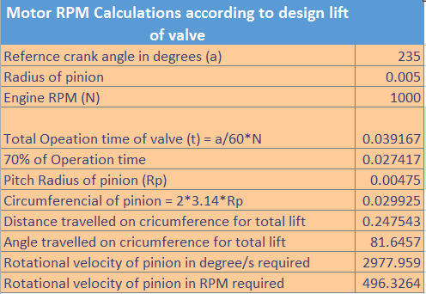

Figure .: Pinion RPM at 1000 Engine RPM with Engine Design Lift

After developing this model we tried it various engine RPMs. For example at 750 RPM.

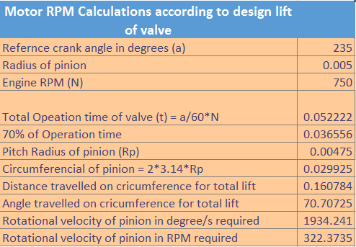

Figure .: Pinion RPM at 750 Engine RPM with Engine Design Lift

In order to find the motor power, linear force calculated above can be used to find torque. Torque when computed with pinion RPM, will give the power.

### Empirical Engine Parameters Based Simulation

Here’s the calculated results based on the lift we measured empirically

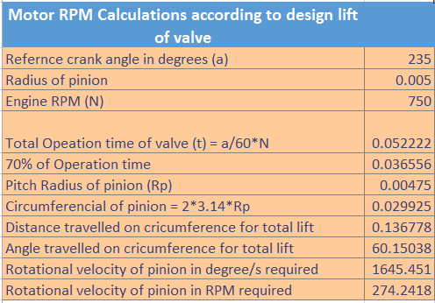

Figure .: Pinion RPM at 750 Engine RPM with Engine Actual Lift

But modelling done on excel didn’t have inertial and frictional forces in it and there was a doubt of error in final parameters. We developed a 3D model and simulated it for motion analysis of model and found all the parameters more precisely.

## Spring Design

### Requirement

The spring is needed to support a load of 145 N with maximum displacement of 15mm.

### Prior Assumptions

Music Wire = A228

From Table, 10-4 of Mechanical Engineering Design by Shigley.

A = 2211 Mpa.mmm where m= 0.145

From table 10-5,

G = 81 Gpa

Taking

* The end square and ground.
* Using the design factor of 1.2
* Taking Robust linearity = 0.15
* Taking as wound spring

### Calculations

Ssy = 0.45 Sut (3)

where $S_{ut}=\frac{A}{d^{m}}$ (4)

d = 2.023 mm (0.08 in) Gauge no 30

where d diameter of wire and is our decision variable

* Putting value of A , d, m in eq. 1 and 2, we get $S_{ut}$ and Ssy
* Ssy = 897.97 Mpa

$C=\frac{2α-β}{4β}+\sqrt{{\frac{2α-β}{4β}}^{2}- \frac{3α}{4β}}$ (5)

* Where $α=\frac{S_{sy}}{n_{s}}$ (6)

and $β=\frac{8\left(1+ξ\right)F_{max}}{πd^{2}}$ $β=\frac{8\left(1+ξ\right)F_{max}}{πd^{2}}$ (7)

* Putting values of Ssy  , , , , d in above equation, we get



$α= 748.11 Mpa$

$β=102.89 Mpa$

$C=5.83$

$$D=Cd$$

* Putting value of C and d, we get value of D = 11.867 mm

$N_{a}=\frac{Gd^{4}y_{max}}{8D^{3}F_{max}}$ (8)

* Putting value of all the parameters in above equation we get

$N_{a}=10.7 turns$

$N_{t}=N_{a}+N_{e}$ (9)

Where $N_{e}=2$ For squared and ground springs

$⟹$ $N_{t}=12.7 turns$

As we know,

$k=\frac{d^{4}G}{3D^{3}N_{a}}$ (10)

* Putting the parameters, we get k = 9.666 N/mm

$L_{s}=dN_{t}$ (11)

$${ L}_{s}= 25.8 mm$$

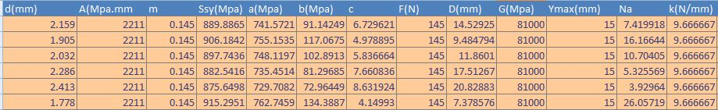

Figure .: Iteration of Spring Design

### Results

Wire diameter d = 2.023 mm

Spring diameter D = 11.867 mm

Spring constant k = 9666 N/mm

Number of turns $N_{t}=12.7 turns$

## PTC Creo 3D Concept Model

In order to get better simulated results, we disassembled the engine and opened up all the components of engine head. 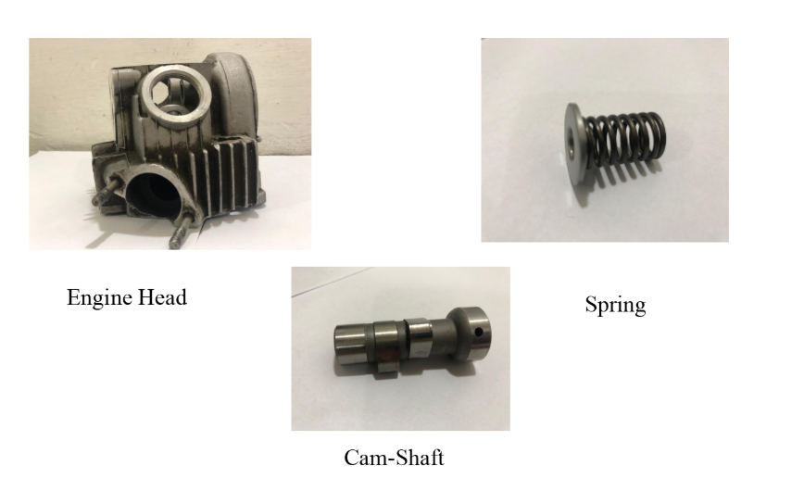

Figure .: Disassembled Components of Engine

Only the valves and the fitting side geometry is of actual dimensions, rest is made as close to actual as possible.

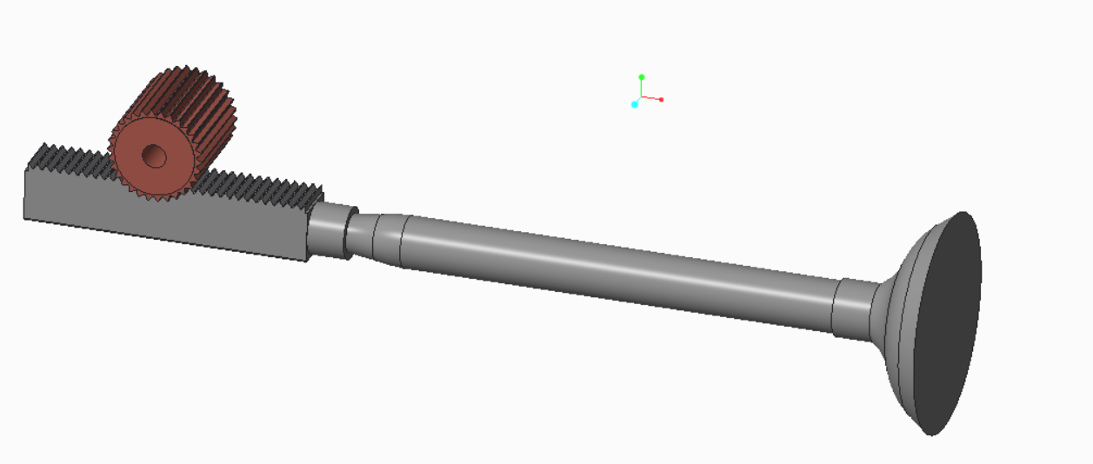

Figure .: Rack and Pinion Assembled with Valve

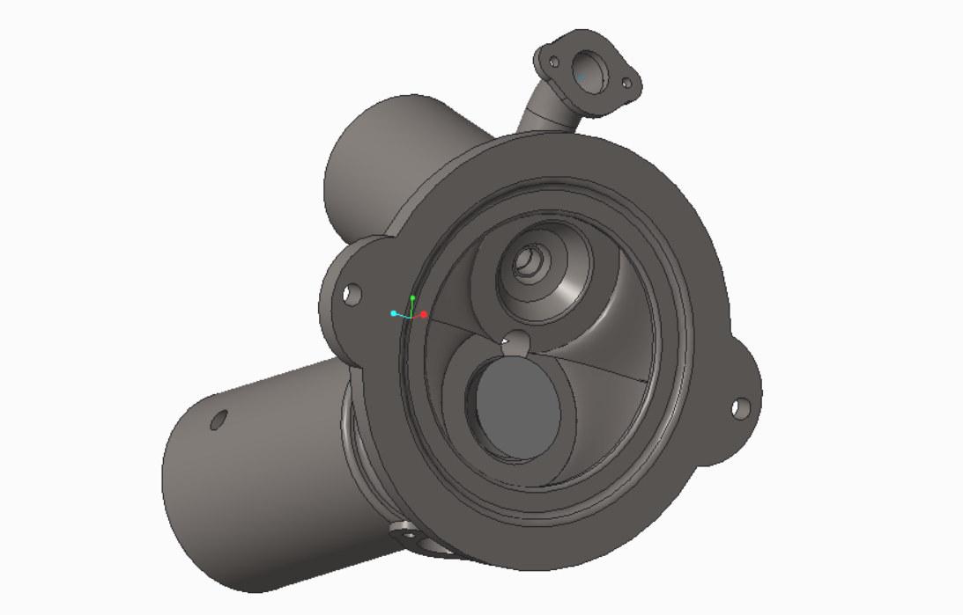

Figure .: Engine Head with valve

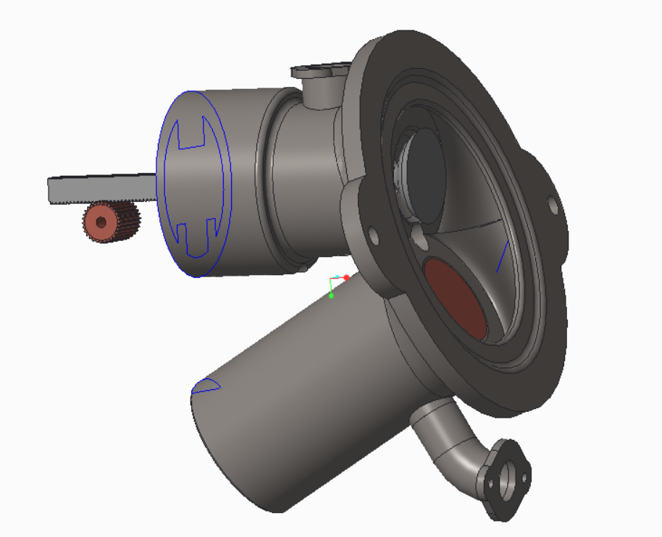

Figure .: Rack and Pinion Assembled into Head

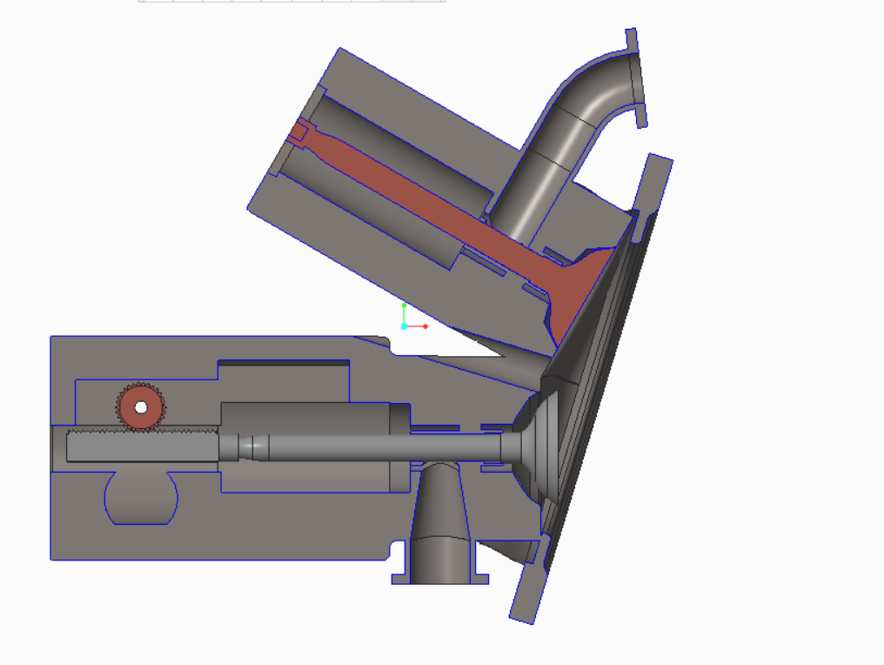

Figure ‎5.14: Sectioned View of Engine Head with both Valves Attached

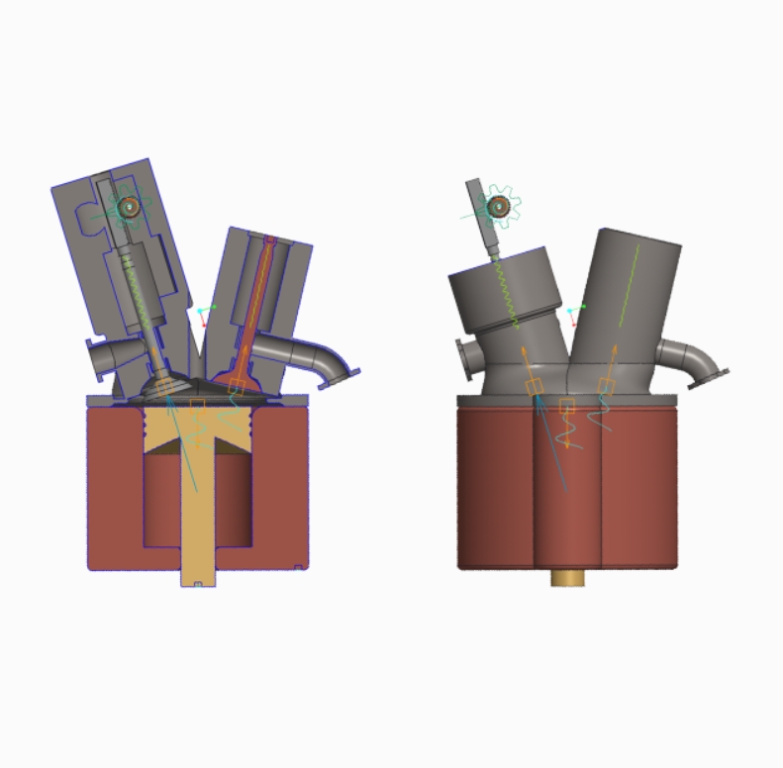

Figure .: Final Assembly in Mechanism Analysis Environment

## Motion Analysis

After completing the required drawings and assembly, we used PTC creo 3.0 software’s mechanism environment to run the motion analysis.

We used the maximum thresholds on which we are going to operate engine.

So RPM had a value of 750.

Crank angle for valve motion was 235.

A valve linear motion of 5mm.

For these parameters we first ran the valve with linear servo motor motion and found the corresponding angle of pinion that would be needed in developing the servo motor profile at pinion.

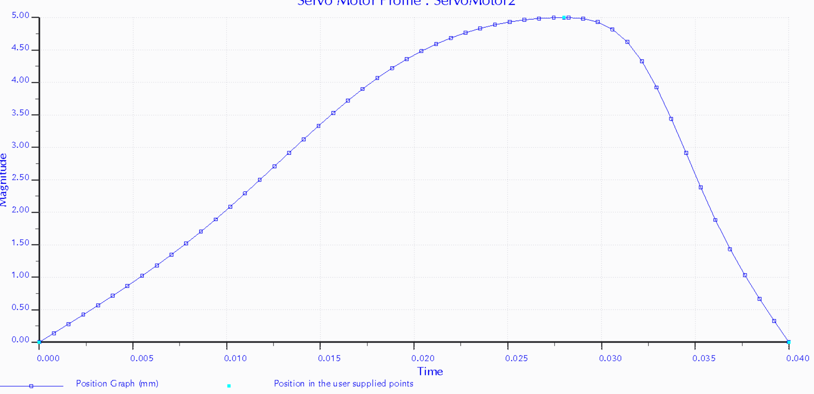

*Figure ‎5.16:* Valve lift vs time Profile at 750 engine RPM for 235 degree Crank angle

Giving above profile generated this graph for servo motor to be attached on pinion

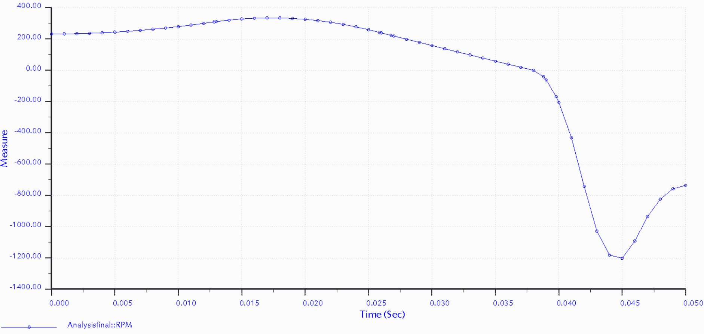

*Figure ‎5.17:* Pinion RPM vs time Profile at 750 engine RPM for 235 degree Crank angle

This is for intake valve and maximum RPM during opening is 235 and 1200 in closing. Closing is swift because it is given lesser time than in opening. Other reason for higher RPM in closing is reinforcement provided by the spring.

## Simulated Results

After the initial analysis we found the profile for max torque and max power required at pinion motor. 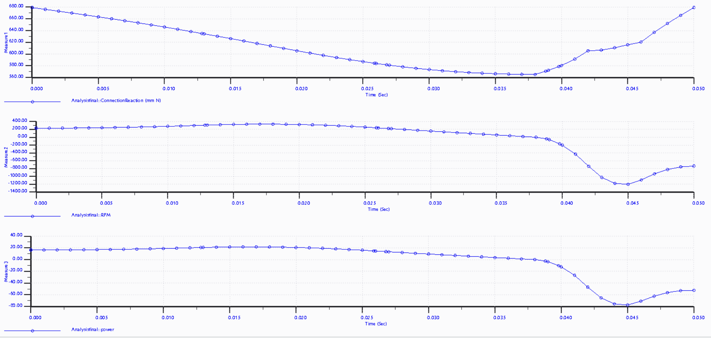

*Figure ‎5.18:* Final Pinion Motor Parameters (Measure 1: Torque in N mm, Measure 2: RPM, Measure 3: Power in Watts

Final results are as follows:

Motor parameters found are as follows:

Max Torque = 1.2 at 560 RPM

Max RPM = 600

Max Power = 80 Watts at 1.2 Nm torque and 560 RPM

## Final Parameters of Mechanical Design

### Springs Parameters:

Wire diameter = 2.032

Springs Diameter = 11.7mm

Design Springs constant = 9.666 N/mm

### Motor parameters

Max Torque = 1.2 at 560 RPM

Max RPM = 600

Max Power = 80 Watts at 1.2 Nm torque and 560 RPM

### Gear Parameters

Pressure angle = 20o

**Pinion:**

Pitch diameter = 12.5mm

Gear teeth depth = 2 mm

Adendum = 1 mm

Dedendum = 1mm

Width of Space = 0.75 mm

Face Width = 5 mm

Gear teeth shape: Triangular

Number of teeth = 27

**Rack:**

Gear teeth depth = 1 mm

Adendum = 1 mm

Dedendum = 1mm

Width of Space = 0.75 mm

Face Width = 5 mm

# ELECTRONIC DESIGN & PARAMETERS

## Electronic Components

Following are the components used in electronic control:

### Microcontroller

Microcontroller will act as a driver of the whole process. It will receive values from CPS and using the algorithm coded on it according to the mathematical equations used earlier in analysis.

We used an Arduino UNO to code the algorithm. On Arduino we installed the PID controls (discussed in following section)

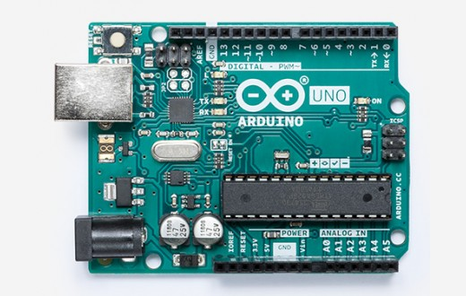

Figure .: Arduino UNO board

For coding this microcontroller, we compiled using Arduino 1.8.9 software.



Figure .: Algorithm Coder Used

### Edge Bridge (IBT-2)

Edge Bridge IBT-2 is a very useful motor driver. It has a function of overheat overcurrent protection.

We used it because we needed strong driving and braking. This bridge is very efficient in this regard. It can be coupled with some switching device like button with the help of Arduino.

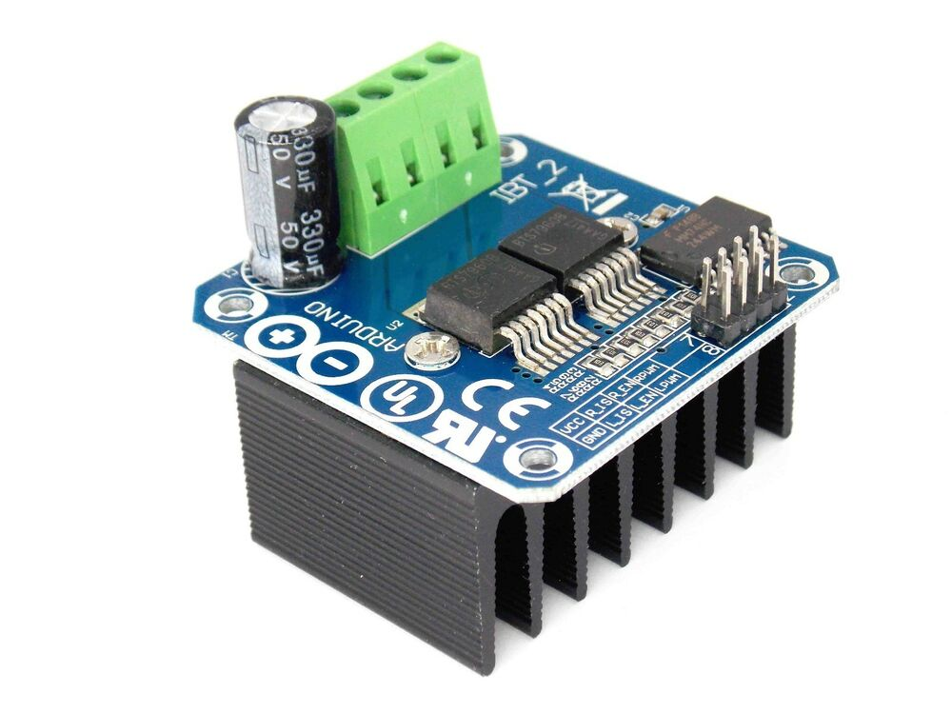

Figure .: Edge Bridge IBT-2

### IR sensor

CPS is this IR sensor. It will read values using different marking done on the sensor plate. Sensor plate is attached with engine crank shaft.

In this way we get the live angle values and those values get fed into Arduino and drive motor with the help of Edge Bridge.

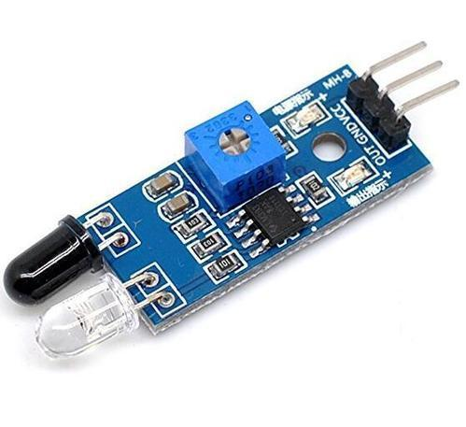

Figure .: IR Sensor

### Motor

We used a DC servo motor having following characteristics:

Max Operating Voltage: 24V

Current Rating: 2.0 +amp

Power Rating: 60 Watt

Max RPM: 2500-3000

## Arduino Code for Edge Bridge

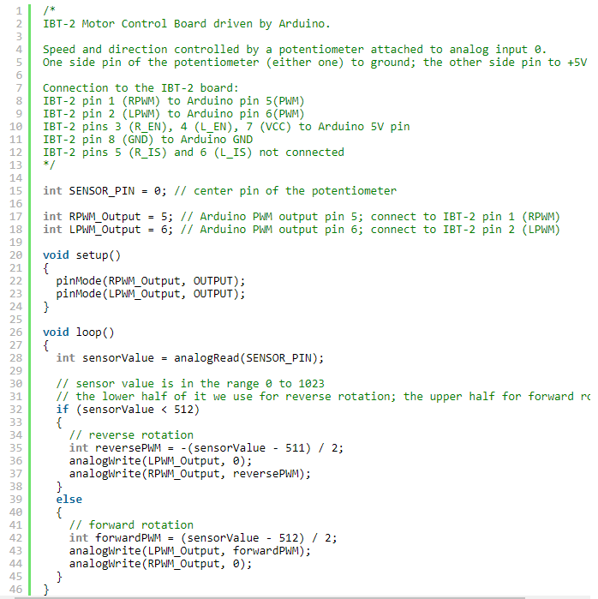

## Circuit Design

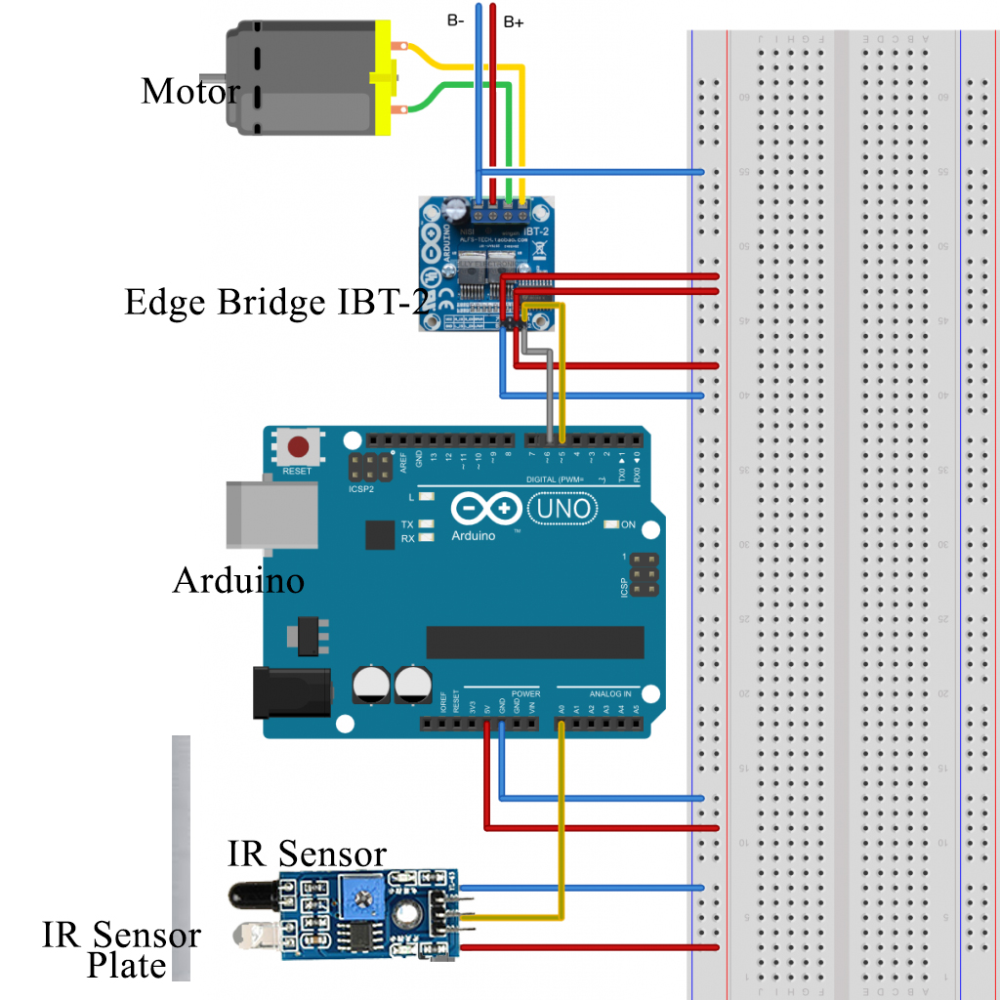

Figure .: Final Circuit Design

# FABRICATION

## Sensor Plate Installation

A plate was to be attached for IR sensor. White and dark areas on plate will b read by IR sensor. These readings will provide the crank angle.

It is made of mild steel and mounted on magnet using bolts and welding process.

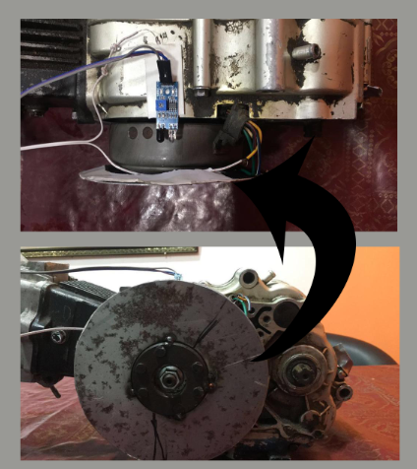

Figure .: IR Sensor Plate Installation

## Motor Installation

Motor is installed on a cast iron plate. Plate is attached using the already available assembly of engine.

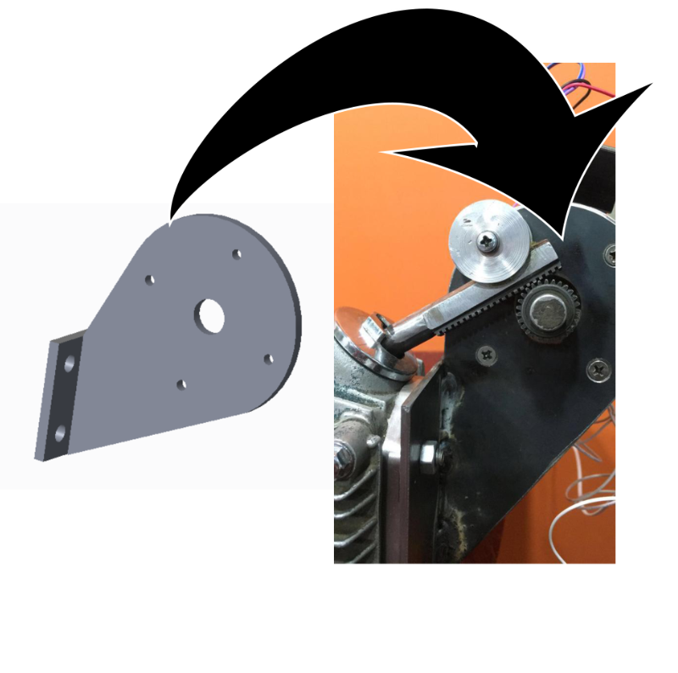

Figure .: Motor Mount Plate installed on Engine

This plate is then used to install motor and bushing which supports rack and keeps it engage with pinion.

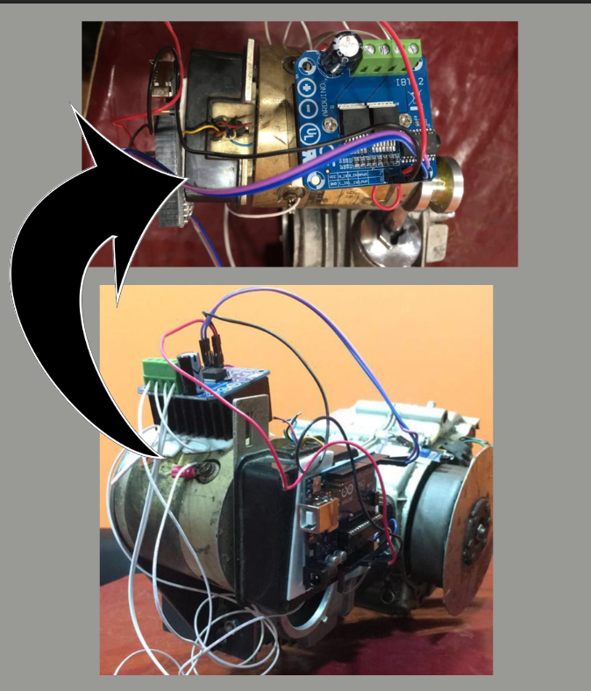

Figure .: Motor Installation

## Rack Installation on Engine Valve

After motor installation rack is welded to valve using a pin joint and whole project is assembled.

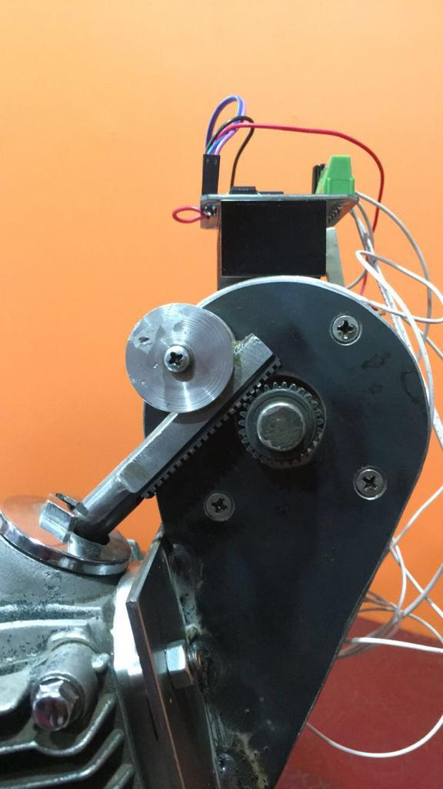

Figure .: Rack installation

## Complete Assembly

Here is the complete assembly with electronics installed ready for testing.

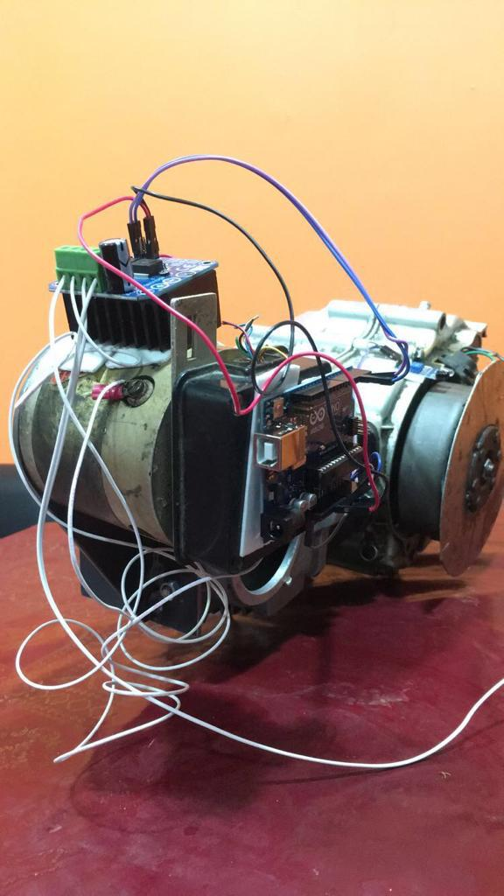

Figure .: Final Assembly of Project

# TESTING

## Mechanical

### Testing

Mechanical testing was done and goals were

* To check if the pinion and rack mesh was operating fine
* To check slipping on pinion.
* To check, if spring was successfully returning the rack or not.

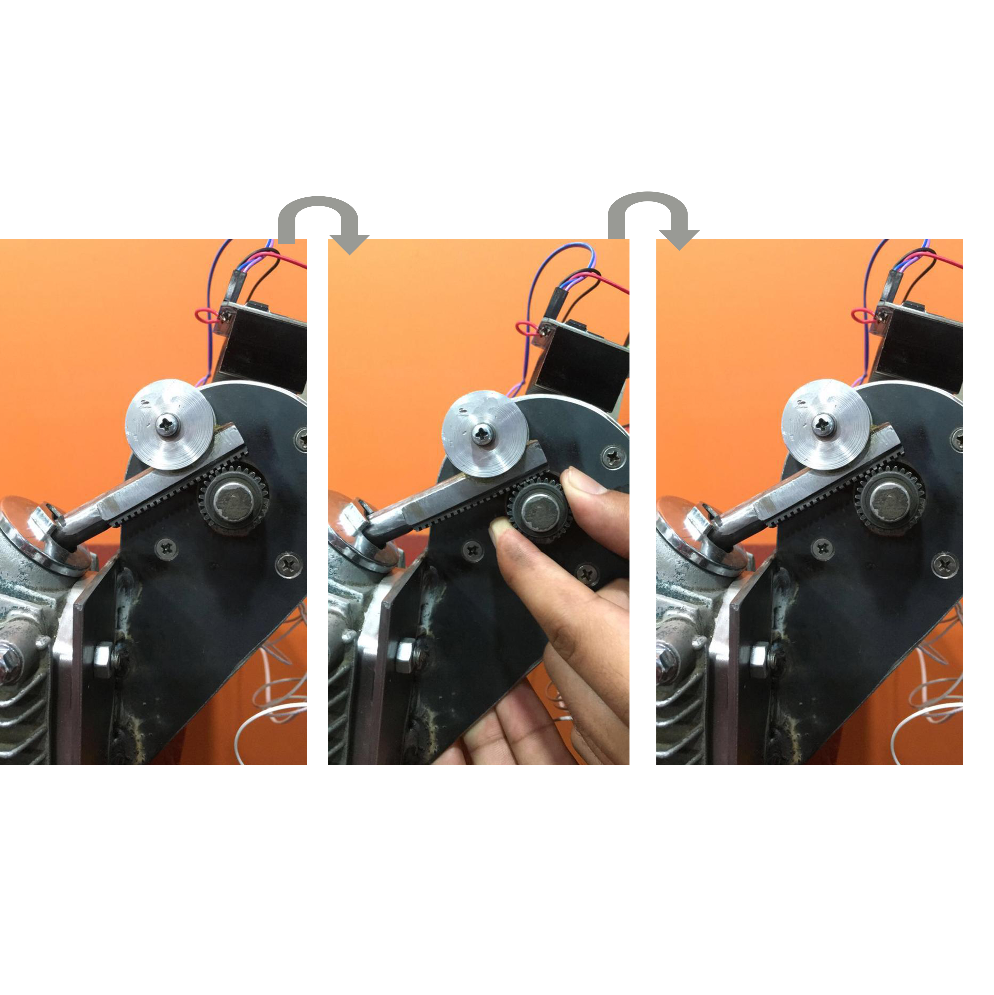

Figure .: Mechanical Testing Illustration

### Mechanism issues

We had following issues:

* Initial spring was quite hard(high spring constant, around 10000 N/m)
* We didn’t install bushing on top to hold the gear mesh and it caused the pinion to slip against rack.

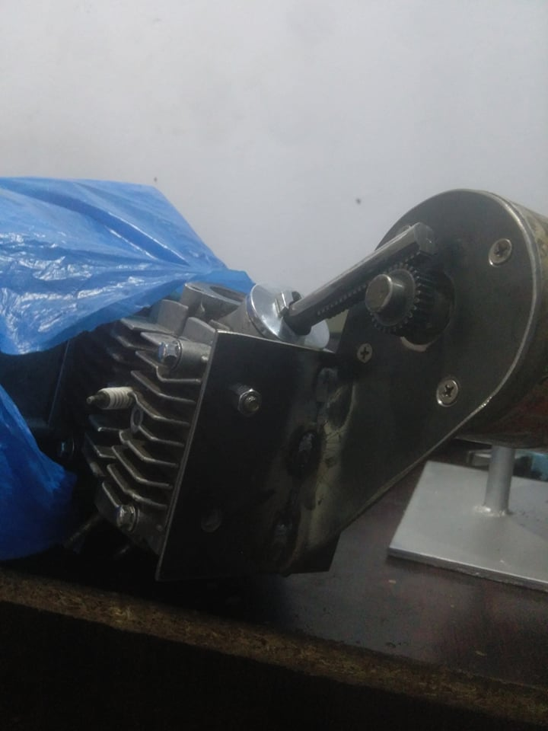

Figure .: Pre Bushing Installation Stage

* After bushing installation, we had some locking issues of the rack, pinion and bushing joint.
* Bushing to tight for the motor to even rotate the pinion and was too tight for spring to return it back using spring force.

We got shoulders of bushing machined and decreased the spring constant to very low, but now the spring constant was to low that it couldn’t return the rack back by itself. We decided to assist it with motor.

## Electronic Testing and its limitations

In electronic testing we first had to check if IR sensor was giving right values needed to switch the motor. We initially used the sensor on random surface and checked its return on laptop using Arduino software.

Motor was test on power supply of 24v and DMM to verify the power ratings.

Edge Bridge is tested after complete circuit assembly.

## Final testing

In final testing we checked if the rotation of plate induced required motion on rack or not. Rack moved fine but due some manufacturing faults in bushing, rack got a slight rotation around its motion axis.

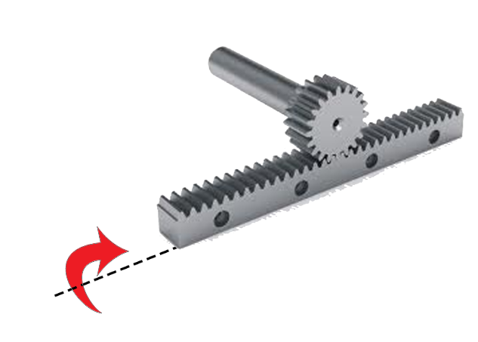

Figure .: Rack axis Rotation Issue Illustration

# RESULTS

* Mechanism fabrication is complete.
* Electronic circuit design and installation is complete and working.
* Valve mechanism is opening and closing valve using the proposed assembly completely.
* Engine’s own assembly is used to install this system resulting in maintaining the size and weight of engine.
* Engine is expected to give 12-15% fuel efficiency improvement when tuned on test bench.

# LIMITATIONS OF PROJECT

* Engine has only intake mechanism automated using cam-less valve mechanism.
* Engine combustion testing is yet to be done as it requires extensive tuning using an engine fuel injection calibration and phasing test bench.
* This system after tuning for fuel injection can operate the engine on minimum sustainable RPM that is 750.This limitation is due to following parameters:
  + Microcontroller Arduino UNO:
    - Has processing limitation of 16Mz
    - It can only regulate a motor of up to 20V. Motor above this voltage will required external power and it will effect motion profile of pinion.
  + Edge Bridge IB-2 has limitations of operating only small motor. If we have to operate the high pressure exhaust valve, motor power will increase and it won’t be efficiently regulated by Edge Bridge.

# RECOMMENDATIONS FOR FUTURE

## Mechanical Components

* Mechanism can be improved by using better component instead of bushing to support the pinion.
* Rack manufacturing quality is low due to fabrication tools limitation. If both the rack and pinion are fabricated using CNC millers, we will have better meshing.
* Instead of making assembly with engine head, we can remove it and design new assembly for our mechanism, which will make engine compact.

## Electronic Components

* Instead of using motor, a custom design and fabricated electronic linear actuator can be used.
* Arduino is not a very efficient micro controller. It can be replaced with some custom design high speed clock processor.
* Instead of using IR sensor to read the crank angle, a rotary or absolute encoder should be used to improve the minimum disturbance limit in motor due crank angle disturbance.
* A hybrid actuator instead of electronic actuator should be used to improve power transmission with respect timing of valve.

## Unlimited Combinations

Conclusively, we think that this project when scaled up can a whole lot of new engineering field opened up.

When a multi- cylinder engine has all its valves actuated using this mechanism, we can have a lot of combinations to optimally operate the engine.

For example, an individual is riding V4 IC engine vehicle want to go in cruise mode. He is low torque requirement and stable speed requirement. With traditional system, all the cylinders will keep on operating and engine will be wasting a lot of fuel. In cam-less system each cylinder will have independent intake and exhaust. To provide the required torque, 2 or 3 cylinders can be turned off and only one cylinder can provide the required torque. Similarly it can serve at low RPM and high torque.

A lot of torque and RPM combination exist during vehicle movement. All these combinations can be integrating using machine learning in controller give optimum operation be precisely changing valve lift, valve timing and number of cylinders with combustion.

# CONCLUSION

Looking back, when everyone except our supervisors said the project impossible to complete we have come a long way ahead. All the traditional engine operate on camshafts and removing camshaft was not very popular idea. Converting a rotary motion to linear motion is best done by rack and pinion mechanism. After having some issues with mechanism testing, it started working fine. Electronic circuit caused the most worry but we got some help and completed that too. Final testing was quite satisfactory. Our results and recommendations of future show that this project can do wonders for automotive sectors.

From business point of view it is expected that world is shifting to electric vehicles. The vehicles based on fossil fuels need to be modified for emissions reduction. This system will be very effective on these vehicles.

# REFERENCES

[1] V. Ganesan, *Internal combustion engines.* New York: McGraw-Hill, 2012.

[2] J. B. Heywood*, Internal Combustion Engine Fundamentals.* Singapore: Mc Graw Hill International Editions, 1988.

[3] W. W. Pulkrabek, *Engineering fundamentals of the internal combustion engine.* India: Pearson, 2017.

[4] *https://en.wikipedia.org/wiki/Camless_piston_engine.*

[5] Noah Joseph. *"Koenigsegg planning four-door model, camless engine".* Autoblog. Retrieved 2017-06-24.

[6] *"Freevalve Update Camless Engine - /INSIDE KOENIGSEGG".* YouTube. 2016-11-09. Retrieved 2017-06-24.

[7] *200mm 12V DC Linear Actuator Motor*: Buy Online at Best Prices in Pakistan. (n.d.). Retrieved from https://www.daraz.pk/products/200mm-12v-dc-linear-actuator-motor-i2744937-s11416412.html

[8] *TowerPro SG90 SG 90 180 Degree Degree Servo Motor. (*n.d.). Retrieved from https://hallroad.org/towerpro-sg90-sg-90-180-degree-degree-servo-motor-in-pakistan.html

[9] W. H. Crouse, *Automotive engine design*. New York: McGraw-Hill, 1970.

[10] G. D. Redford, *Mechanical engineering design*. London: Macmillan, 1973.